DTIS – DIRECTORATE OF TAXATION INFORMATION SYSTEM

USER´S GUIDE

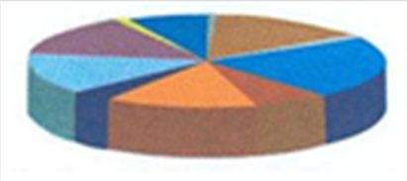

**Updated Version 1 & 2 - Including Sales and Excise Taxes, Reconcile Bank Deposits, Send SMS, Import Payment Data and Export Registration Data for External Entities.**

**10/16/2013**

This publication was produced for review by the United States Agency for International Development. It was prepared by the advisor(s) supporting USAID’s Economic Governance Project in South Sudan. The author’s views expressed in this publication do not necessarily reflect the views of USAID or the United States Government.

|  |  |  |
| --- | --- | --- |
| Authors |  |  |
| Maria Elisabethe Hartmann Pires  Tax Advisor, State Coordinator  USAID / CORE II Project in South Sudan  bethe.pires@gmail.com |  |  |

|  |  |  |  |
| --- | --- | --- | --- |
| Date | Document Version | Document Revision Description | Document Author |
| 29/07/2013 | Version 1 | Includes features of Sales and Excise Taxes | Bethe Pires |
| 10/10/2013 | Version 2 | Includes features of Reconcile Bank Deposits, Send SMS, Import Payment Data and Export Registration Data for External Entities | Bethe Pires |
|  |  |  |  |
|  |  |  |  |

**Disclaimer**

The author’s views expressed in this publication do not necessarily reflect the views of USAID or the United States Government.

**The examples and figures used in this guide do not reflect true data and it is intended for internal use only.**

TABLE OF CONTENTS

Getting Started 6

System Overview 7

Taxpayer Registration Module 7

Taxpayer Accounts Module 8

Common Features throughout the System 8

SEARCH 9

ADD NEW 12

VIEW 13

EDIT 15

PRINT 16

Identification and Password 17

DTIS 17

Windows 18

Users, Profiles and Privileges 20

Registration Viewer 20

Registration Data Entry 20

Tax Accounts Viewer 20

Accounts Data Entry 20

Accounts Manager 20

Branch Administration 20

Auditor 20

Taxpayer Registration Module 21

Main Features 21

Basic Concepts in Producing Reports 28

GROUP 28

SORT 28

FILTER 28

ORDER OF CHARACTERS 28

Examples of Reports 29

Taxpayers Accounts Module 34

Process Return 34

Payments 39

MANAGE PAYMENTS 39

RECONCILE BANK PAYMENTS 42

Taxpayers Accounts 46

CALCULATE CHARGES FOR ALL TAXPAYERS 49

CALCULATE CHARGES FOR ONE SINGLE TAXPAYER 53

TRANSFER CREDIT 55

Audit 59

Reports 65

TAXPAYERS ACCOUNT REPORT 66

ANNUAL REVENUE REPORT 68

STOP-FILERS / NON-FILERS REPORT 69

PAYMENTS REPORT 74

TAXPAYER DASHBOARD 79

Send SMS 84

Frequently Asked Questions 85

1. How do I get taxpayers returns submissions? 85

2. How do I get an Audit assessment return? 85

3. How to find out about partial payment of taxes? 85

4. How to know about late payment of submitted returns? 85

5. How to list non-filers and late filing of tax returns? 85

6. How do I make a report to select a subset of taxpayers that meet some specific criteria? 85

7. What is an uncalculated period? 85

8. What investigations and research can be made using the System that could lead to an Audit Assessment? (See Clearance Procedure Guide) 85

# Getting Started

The Directorate of Taxation Information System (DTIS) is a very important system as it contains confidential information about taxpayers such as registration, returns, audits and payments. Therefore it should be exercised great care in its usage as it contains essential information for the tax administration.

The following chapters will address the most important features of the system and its practical usage within the tax administration daily operations. It is not an exhaustive guide with all possible options, but a simplified guide that intends to provide practical guidance on its usage to the tax officers.

The System has two main Modules: Taxpayers´ Registration and Taxpayers´ Accounts.

The user will access one or both modules according to the privileges assigned to him/her identification (user ID and password). Again, within each module the user will access features according to the privileges assigned to him/her.

It is a similar procedure to access each module as described below:

1. Click on the corresponding icon of the module you want to use on the computer´s desktop



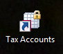

1. Login providing your user ID[1] and password



# System Overview

See below the diagrams with an overview of the structure and functionalities of each module of the system:

## Taxpayer Registration Module

## Taxpayer Accounts Module

## Common Features throughout the System

Some operations like SEARCH, ADD NEW, VIEW, EDIT and PRINT are present on different functionalities of the System and can be understood in a generic way. In other words, when dealing with Taxpayer Registration, Payments, Taxpayers Accounts and Audits we can perform these same operations.

### SEARCH

One very important operation is SEARCH as it enables us to find the information we are looking for. In all cases we can search by TIN - Taxpayer Identification Number, by Business Name (Official name of the business or name of the sole proprietor) or by Trading Name of the business.

Then there is some specific information that varies according to the type of information you are looking for. For instance, in Payments you can also include Payment Date as search criteria and in Accounts we can have Type of Tax as search criteria.

**TAXPAYER SEARCH**

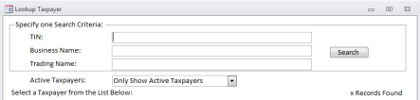

**PAYMENTS SEARCH**

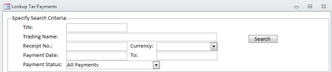

**ACCOUNTS SEARCH**

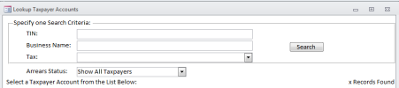

**AUDIT SEARCH**

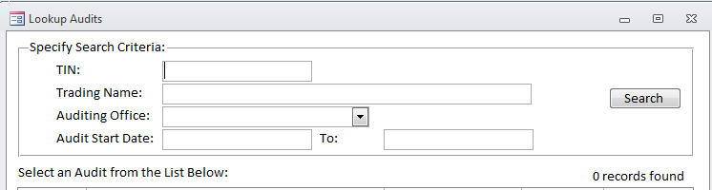

If the **TIN** is known then the search is immediate, just fill in the Taxpayers´ Identification Number. In some cases the TIN is unknown at first, so we may search by:

a) **Business name**, type in all, or part, of the name, using one word of the name business or even part of a word;

b) **Trading name,** type in all, or part, of the name, just as in the case of doing a search on Business Name (see ‘a’).

1. If we search AFEX as **business name** no records will be found as there is no company in our records with a business name having AFEX as part of their business name. The Business Name is the legal name of the company, while the Trading Name is the common name it operates under (almost like a nickname).

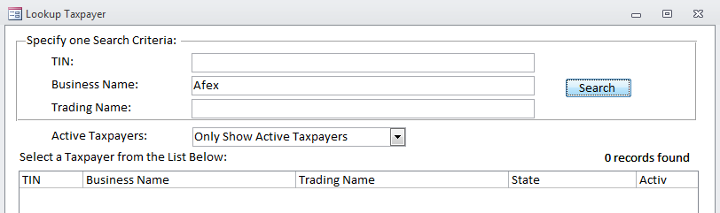

1. If we search AFEX as **trading name** two records will be found and we must decide which one we are looking for, if any.

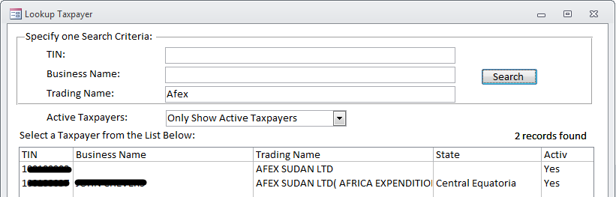

1. Sometimes we are not sure about the name but we know it is a hotel, a restaurant, so we can try a more generic word and we will get a broader list. Searching for HOTEL we found 121 records in this case[2].

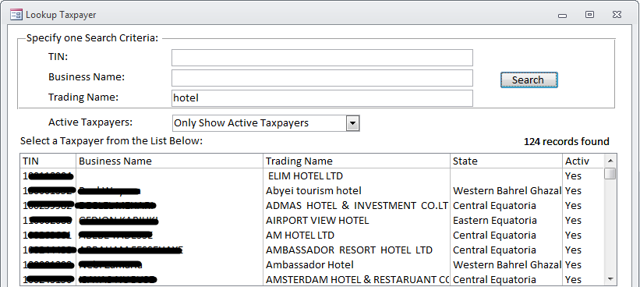

1. If you simply click SEARCH without informing any search criteria, all records in the database will be retrieved (in this case, 10.324 records were found), classified by TIN.

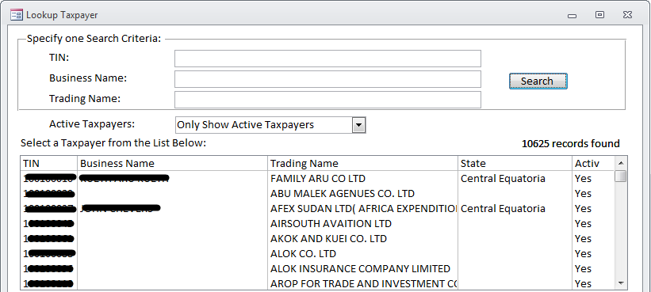

1. Let us imagine that we are willing to find a specific oil company. We could look for the word (or pieces of word) such as “petro”, “oil”, “oleum” and “petroleum” and would get different results. Note that singular brings better results than plural (“bank” versus “banks”).

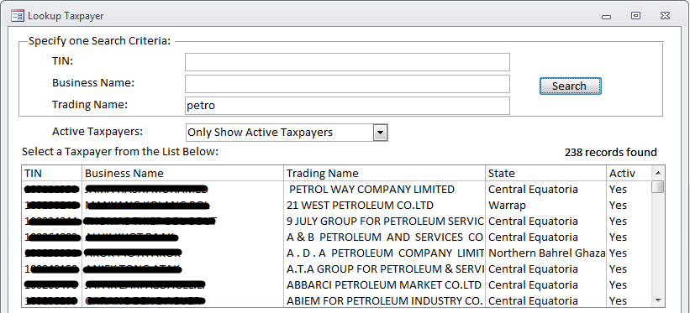

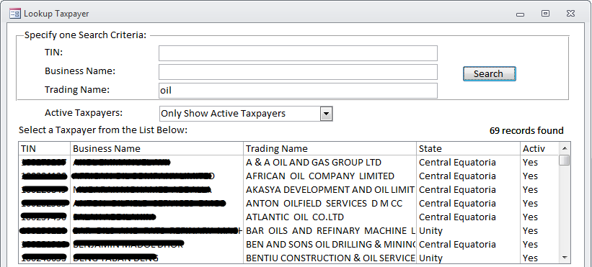

### ADD NEW

This operation enables us to include **new** information in the database such as:

1. A new **taxpayer** to whom will be automatically assigned a unique and new TIN;
2. A new **payment** for an already existing taxpayer that refers to a specific tax, a certain period and a unique receipt number, so the system will automatically assign it an unique internal identification number;
3. A new **audit** for an already existing taxpayer that refers to a certain period, and performed by a certain auditor, so the system will automatically assign it a unique internal identification number.

In short, ADD NEW means that unique information is being introduced into the System.

### VIEW

This operation enables us to view preexisting information within the database. This information can be of a taxpayer registration, a payment, an account and an audit. Generally the SAVE button is disabled, therefore the information cannot be changed, just viewed. This operation is available to all users most of the time.

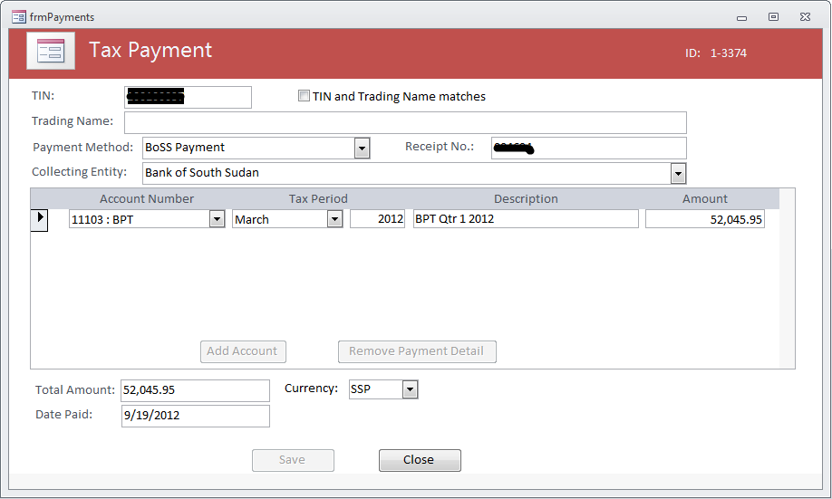

In the case of a taxpayer registration the VIEW operation also works as an EDIT operation, so it is called VIEW/EDIT. An EDIT operation is usually only available to officers responsible for the data entry.

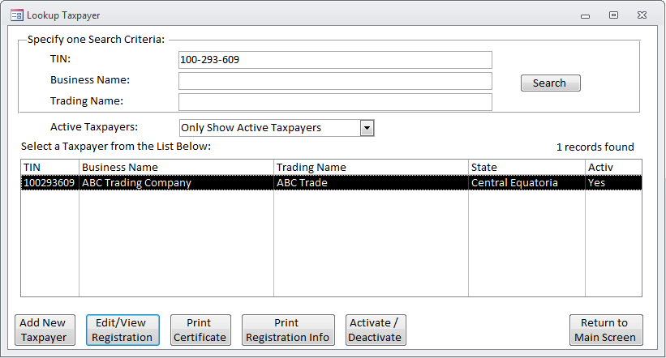

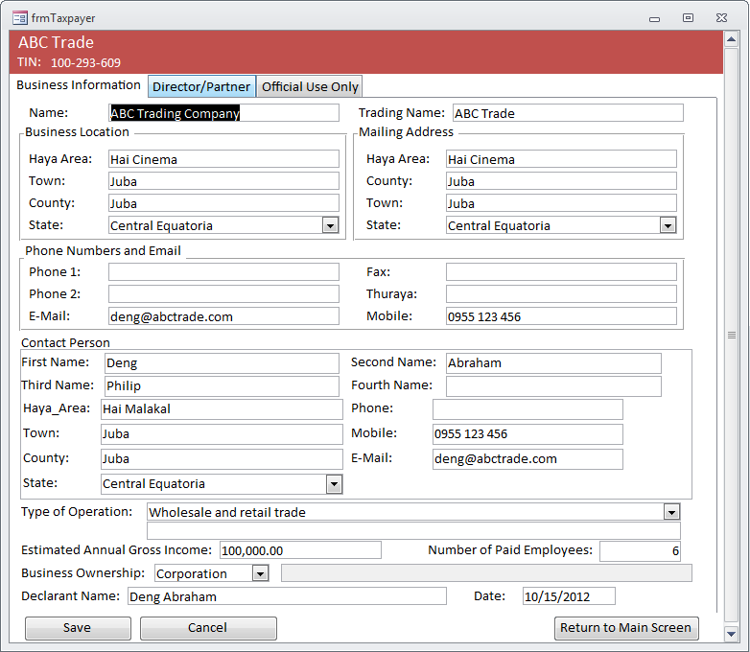

In this case, one must save the information that was modified.

### EDIT

This operation enables us to modify preexisting information within the database therefore the SAVE button is enabled. This information to be changed can be of a taxpayer registration, a payment, a return, an account or an audit. This operation is usually only available to officers responsible for the data entry.

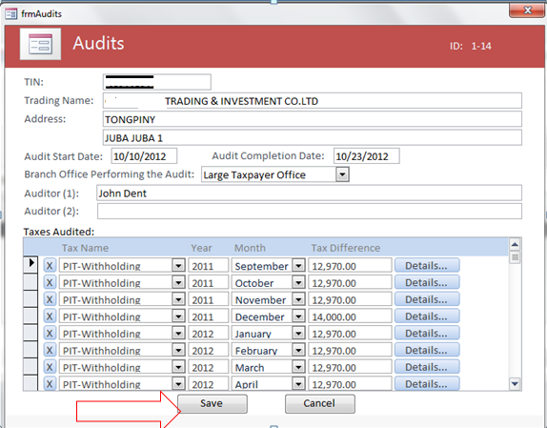

**Note: In this specific example you must SAVE the DETAILS (as below) screen and the screen that contains the list (as above).**

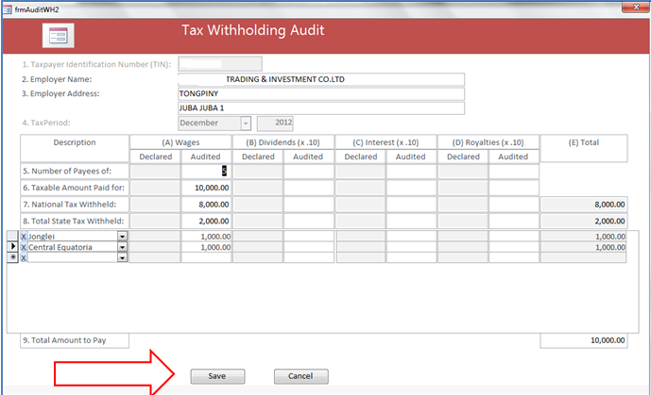

### PRINT

This operation enables the printing of a screen or a report both in paper or PDF[3] file. By default the information will be displayed for visualization on the screen. If you wish to print it, you must select PRINT and then choose the printer or the PDF format. You may just close the visualization by pressing “CLOSE”

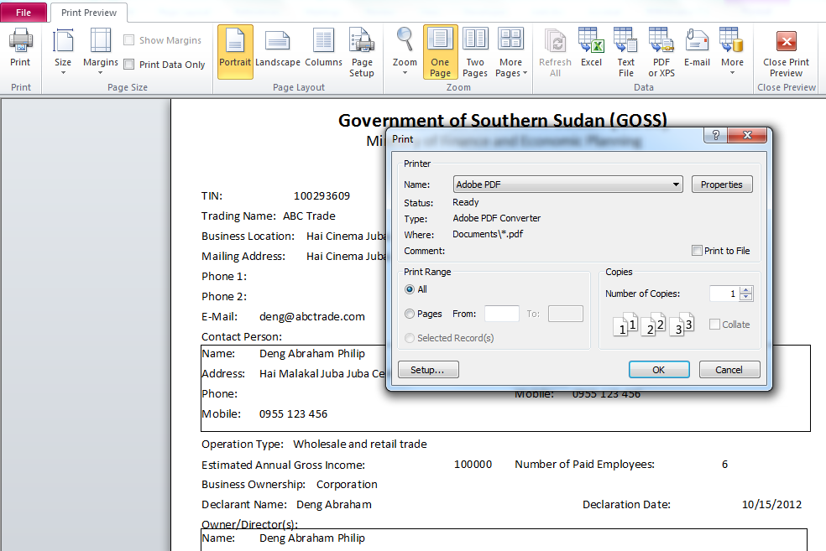

In this example a PDF file will be generated and it can be printed later on as any other document.

On this screen you could choose (instead of PDF) a printer from the drop-down menu and the document would be immediately printed.

# Identification and Password

Make sure that these passwords are changed frequently (at least once a month) and that you remember them by heart.

## DTIS

The user ID has to be the actual name of an individual in the Tax Directorate; it shall not be used generic names such as “Tax Officer” to be used by many different people. It will be provided to the end users by the System Administrator with a temporary password that you must change immediately.

Your ID and password are private, therefore it is very important that you keep your user ID and password secret. **You will be responsible for whatever happens in the system under the usage of your user ID and password. You should be as careful with this password as you are with your bank account or wallet**.

Remember that the System has audit log reports of every transaction performed by any user at any time in order to trace back any attempt of fraud. So whatever is done under your ID and password will be accountable solely to you.

Keep in mind that the information stored in DTIS is highly confidential and sensitive as it deals with taxpayers, returns and payments, so all care should be exercised.

1. The user of the system can change his/her password at any time. Just choose this option in the main menu as below:

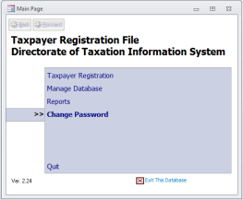

1. And the CHANGE PASSWORD SCREEN will be displayed. Complete the fields accordingly and press SAVE.

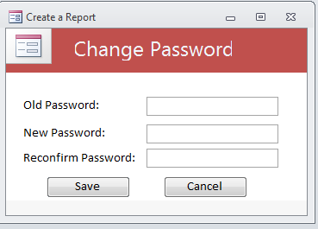

## Windows

A password should also be defined for Windows Operating System in your notebook or desktop computer. It is your first level of protection as it will prevent other people of accessing other data in your computer than DTIS as, for instance, a document or a spreadsheet.

Click on the WINDOWS icon at the very left bottom corner of the screen and select CONTROL PANEL as below:

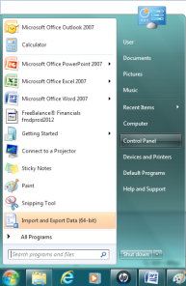

In the CONTROL PANEL select USERS AND ACCOUNTS

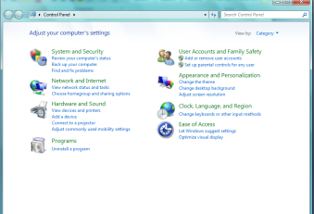

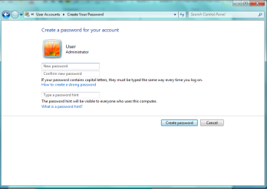

Make sure you have a strong password and fill in your password hint as explained in the screen.

# Users, Profiles and Privileges

A USER is a specific and real person namely an employee within the Directorate of Taxation at the Ministry of Finance. Every user that is registered into DTIS has an USER NAME (birth name) and an USER ID (standing for Identification). The USER ID is some sort of nickname that the person will have within the system.

Every user is associated to one or more profiles and this will define the privileges that she or he will have in using the system. Privileges are often also referred as permissions to access the system. Only the System Administrator can create users and manage their privileges. There are a number of pre-defined profiles in the system and the administrator shall select among these options the privileges that will be assigned to that user.

### Registration Viewer

It is a tax officer that has permission to **view** registration data of **all** taxpayers.

### Registration Data Entry

It is a tax officer that can update some registration data of taxpayers. This operator can enter new taxpayers from any office, but can only edit taxpayers assigned to his/her office.

### Tax Accounts Viewer

It is a tax officer that has permission to **view** data of **all** taxpayers´ accounts.

### Accounts Data Entry

It is a tax officer that can update some taxpayers´ accounts data. This operator can enter new payments for all offices, but can only edit or enter new returns for his/her assigned office.

### Accounts Manager

It is a tax officer that has specific privileges such as reversing transactions, editing payments, etc.

### Branch Administration

A tax officer with full power upon all taxpayers assigned to that branch.

### Auditor

A tax officer assigned to enter audit reports for all taxpayers.

# Taxpayer Registration Module

When registering a taxpayer it should be exercised great care in getting the correct information into the System.

## Main Features

1. After you successfully log into the Registration Module using your User ID and password, the MAIN MENU screen will be presented

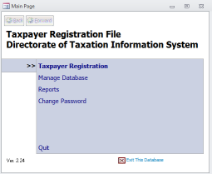

1. Select the option TAXPAYER REGISTRATION. We are looking for the data of a taxpayer that we do not know the TIN number, but we know that has the text “CIVI” in its trading name. After pressing the SEARCH button, a list of possibilities is displayed.

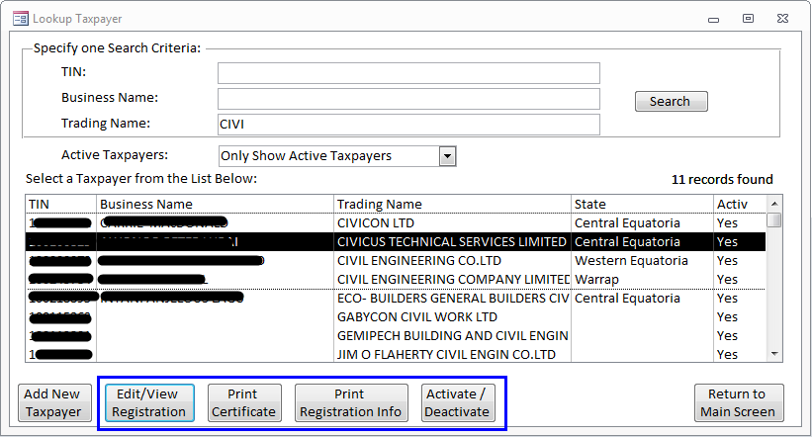

Click with the mouse on the line of the taxpayer you were looking for. In this case it is CIVICUS TECHNICAL SERVICES LIMITED. At this point you can perform any of the operations marked in the box (EDIT/VIEW, PRINT CERTIFICATE, PRINT REGISTRATION INFO and ACTIVATE/DEACTIVATE). Just press the button and the corresponding screen will be displayed.

1. As for instance, if you click EDIT/VIEW you will see all registration information about that taxpayer. Please note, as marked in blue, that there are 3 folders of information: Business Information, Director/Partner and Official Use only.

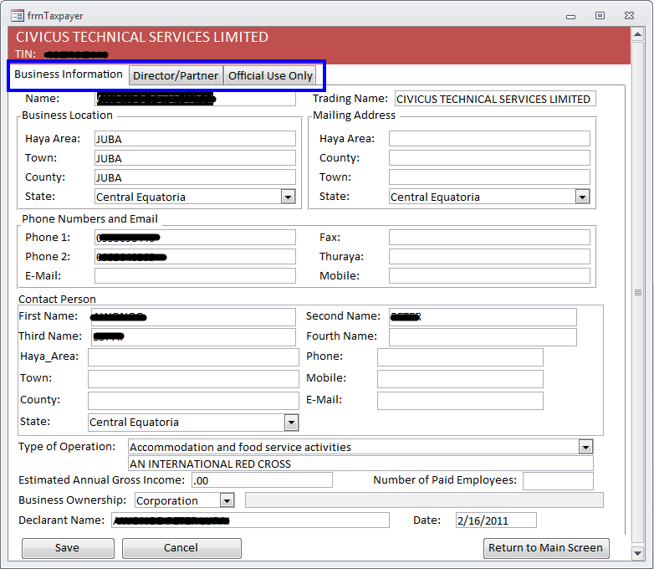

If you want to change some information press SAVE before exiting the screen, otherwise press CANCEL (it will return to the previous screen with the search) or press RETURN TO MAIN MENU.

1. To include a new taxpayer just press the corresponding button and an empty screen, composed of 3 folders, will be prompted to be filled. Please note that at this point TIN is only zeros. When you are finished press the SAVE button, then an UNIQUE TIN NUMBER will be given to that NEW taxpayer.

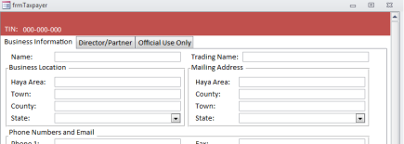

**Make sure when registering a taxpayer that:**

On folder BUSINESS INFORMATION:

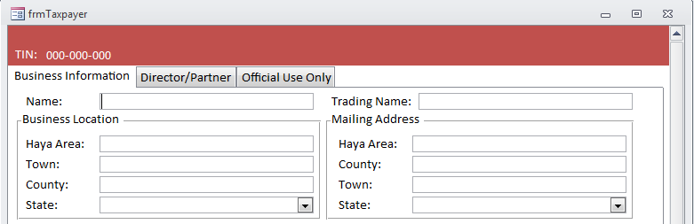

* NAME - is the name of the taxpayer **as registered with the Business Registry** (Ministry of Justice) and NOT the name of the person that is registering the business such as its manager, accountant or lawyer. Example:  **Royal Dutch Petroleum Company**
* TRADING NAME - it is the name by which the business is mostly known in the market. Example: **Shell**
* Please note that in many cases involving a **legal entity**, the business name and trading name can be the same;
* In cases involving **sole entrepreneurs**, the individual owner’s name will appear as business name. The trade name can be the same or not.

On folder DIRECTOR/PARTNER:

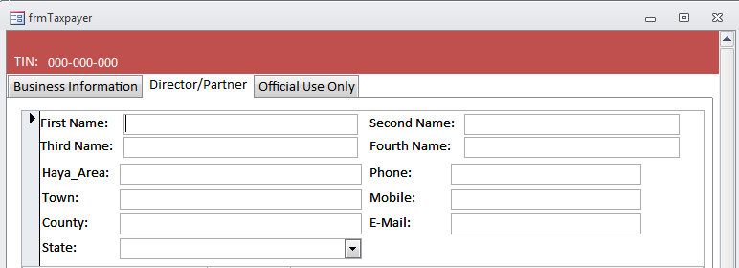

* First, second, third and fourth Name - the corresponding pieces of the full name of the individual person that is the director, partner or sole owner of the business.

**Example of correct registration of a legal entity:**

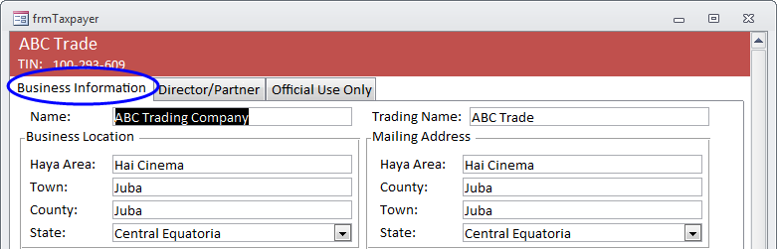

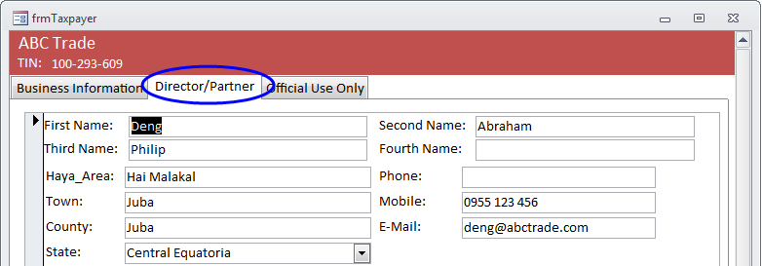

**Example of correct registration of a sole entrepreneur:**

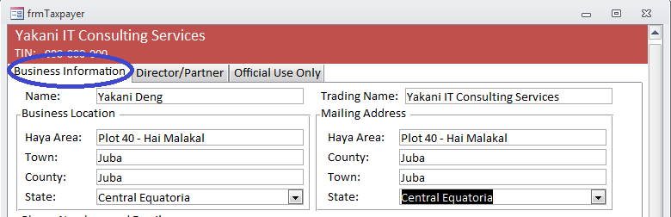

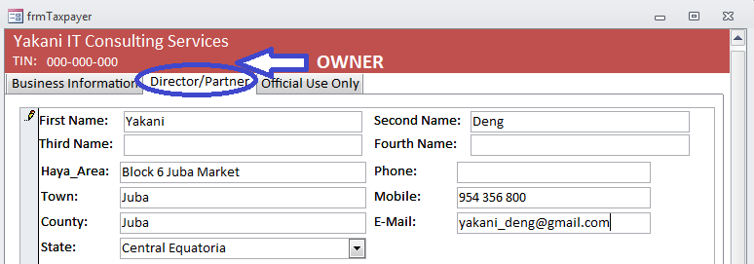

1. If you want to PRINT A CERTIFICATE or REGISTRATION INFO, just click the corresponding button and a printing preview will be displayed. You now can print the document in in paper or PDF[4] file; you must select PRINT and then choose the printer or the PDF format. If you don´t want to print you can exit the preview by pressing the “Close”

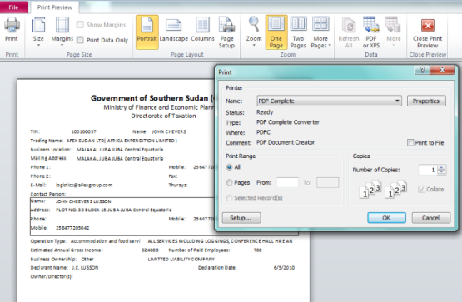

1. Make sure you **do not close** the entire screen by pressing the X at the right upper corner as this will close the entire module in an unexpected way and data may be corrupted, since the proper way of leaving the module is through the QUIT option.

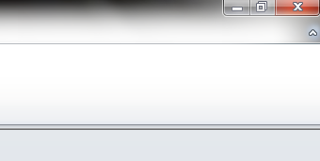

1. To ACTIVATE/DEACTIVATE a taxpayer more privileges maybe required, therefore this option would be disabled in most cases. If your profile permits the following screen will be displayed

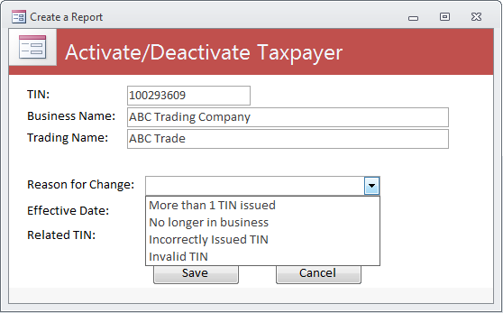

The tax officer must select the reason for the activation or deactivation; inform the date and the related TIN, would that be the case.

1. If we go back to the MAIN MENU, we can select REPORTS.

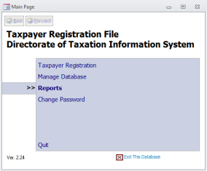

1. At present there is only one report that we can select: Taxpayer Register, but it is a very dynamic report with several options for you to configure it as needed.

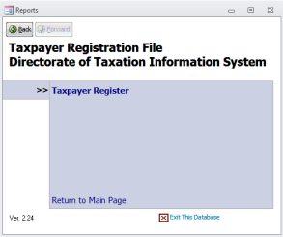

1. The following screen would be displayed for configuration of the report

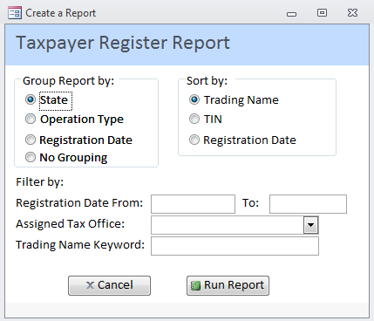

Before we configure the options we must understand these basic concepts in producing reports and see same examples.

## Basic Concepts in Producing Reports

### GROUP

Itdefines how we want the information to be grouped at its highest level. In this example the report can be grouped by **State**, by **Operation Type[5]** and by **Registration Date.** We may decide not to group the information and in this case only the sort classifier will be used.

SORT

It defines how we want the information to be sorted or ordered within the group. If no grouping is selected, the sort criteria will apply the same way. The information classified by **Trading Name**, **TIN** and **Registration Date**, always in **ascending order**. One classifier must be selected.

### FILTER

It establishes a criterion to select SOME (not all) specific records within the data base. In other words, we filter the information that will be printed. In this example we can filter the report by **Date** and by **Tax Office**.

### ORDER OF CHARACTERS

The basic order of characters should be in the following sequence:

* spaces
* symbols other than numerals, letters, and punctuation marks
* numerals (0 through 9)
* letters (A through Z)

## Examples of Reports

1. **REPORT GROUPED BY STATE, CLASSIFIED BY TRADING NAME, NO FILTER**



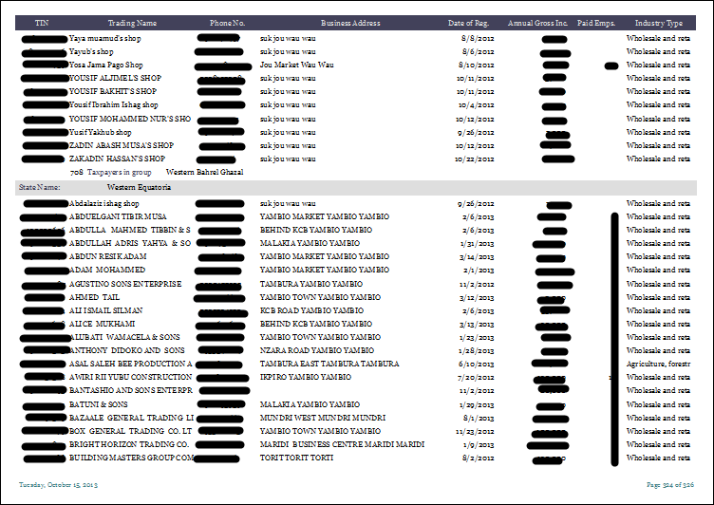

This is page 324 of the report. We see the last Taxpayer of Western Bahr el Ghazal and the beginning of the taxpayers´ list of Western Equatoria (letter A). Subtotals are provided at the end of each group as well as a grand total at the end of the report.

The first 26 pages of the report (814 taxpayers) are grouped at State “BLANK SPACES” in the sense that they were registered with no state; therefore all taxpayers with no state informed are listed together. On the alphabetical order Blank Spaces come before the letters. Numbers come before letters. Special characters (# “ “ $ &, etc.) come before numbers.

1. **REPORT GROUPED BY STATE, CLASSIFIED BY TRADING NAME, FILTERED BY LARGE TAXPAYERS UNIT**

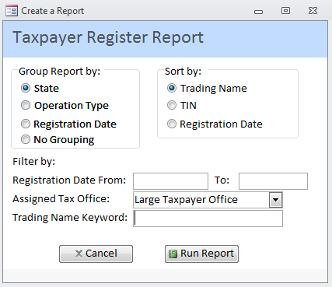

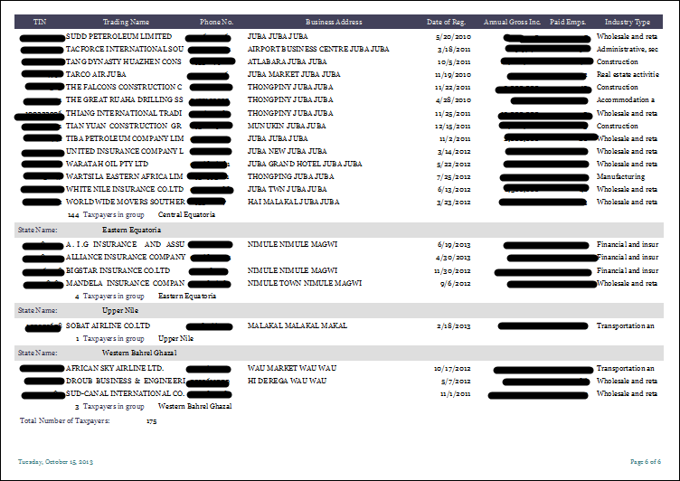

This report only has 4 pages as it was filtered by Assigned Office equal to Large Taxpayers Unit. It has in total 107 large taxpayers: 78 in Central Equatoria, 2 in Western Bahr el Ghazal and 27 with no State.

This is first page of the report. It has 27 taxpayers without the information of the state as you can see marked in blue. **This is to emphasize that the input of incorrect or incomplete information will result in poor reports as this one.**

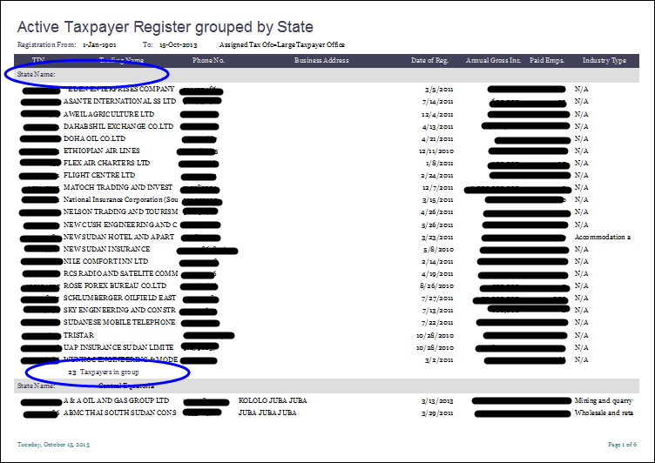

This is just another report. **Note that numbers would come before letters when sorted in ascending order.**

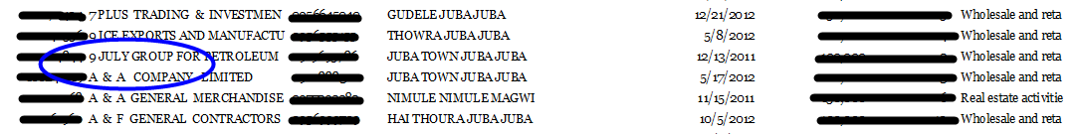

1. **REPORT GROUPED BY OPERATION TYPE, CLASSIFIED BY TIN, FILTERED BY LARGE TAXPAYERS UNIT**

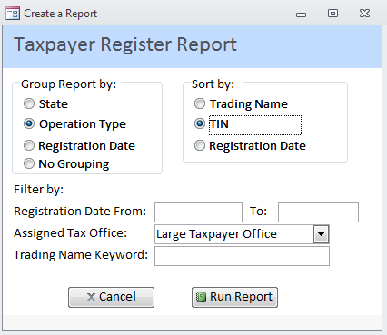

The report has 5 pages. Note that no date was used to filter the information; therefore it has information registered since the very start of the database up to this day. It is grouped by type of business operation (accommodation and food, construction, financial services, etc.) and classified (sorted) by TIN, not by trading name.

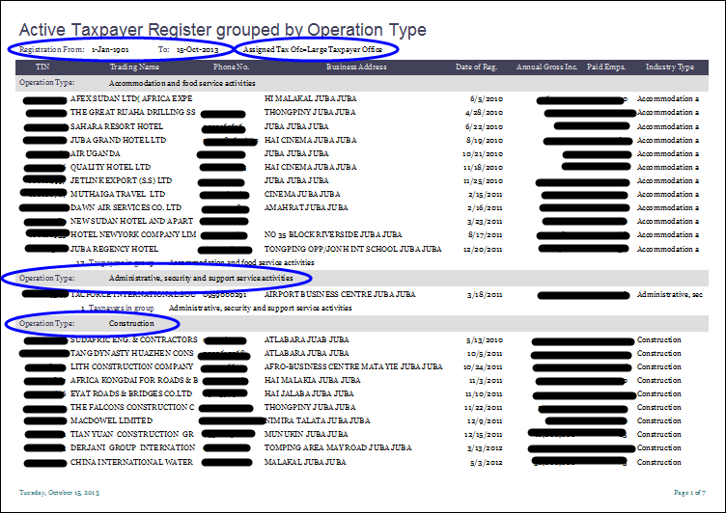

1. **REPORT GROUPED BY OPERATION TYPE, CLASSIFIED BY TRADING NAME AND FILTERED BY KEYWORD “PETRO” WITHIN TRADING NAME**

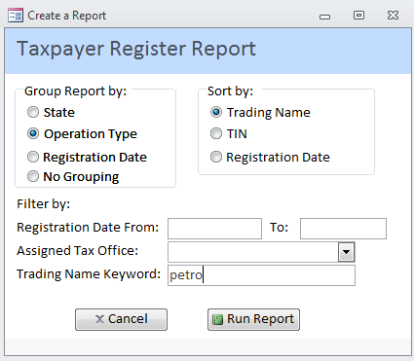

A nine page report would be generated listing all taxpayers that have the text string “petro” within their trading name grouped by operation type. As we can see many business were originally wrongly classified therefore and gradually must be corrected.

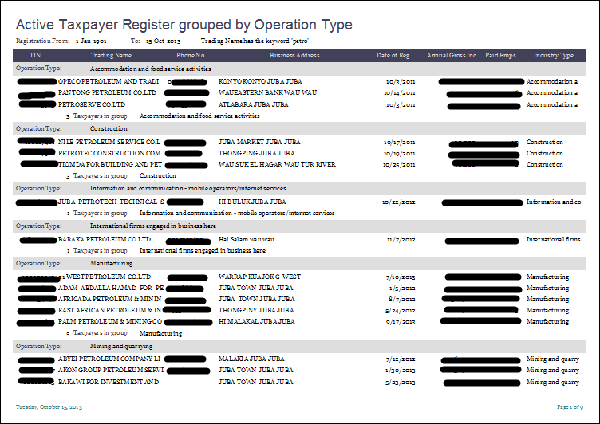

# Taxpayers Accounts Module

This module has the following main functionalities for regular users (not administrators): PROCESS RETURN, PAYMENTS, ACCOUNTS, AUDIT and REPORTS. After you successfully log into the Accounts Module using your User ID and password, the MAIN MENU screen will be presented:

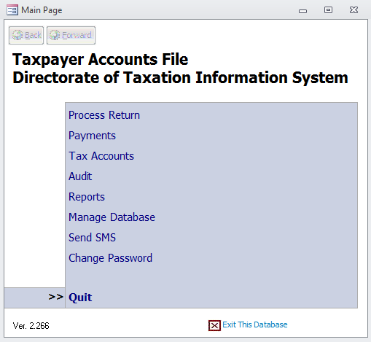

## Process Return

Through this option all returns (declarations, statements) are included into the System. It is an ADD NEW feature for PIT-Withholding, Excise Tax, Annual BPT - Business Profit Tax and Sales Tax. Please note that the old forms are still available, but will be discontinued later.

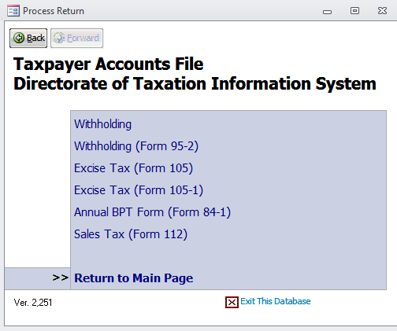

This feature is only used by the Data Entry Section and requires a lot of attention to be typed in as most returns have a lot of detailed information. It is basically a mirror of the paper form and once all information is typed it must be SAVED. Since this is a specialized work it will not be covered in detail on this Guide and specific training is provided for the few authorized users that perform the data entry.

1. Below an example of ADD NEW of Annual Business Profit Tax. Please note the great amount of information that is included in the database through this form: it has the main tab (section 1) and 6 other tabs.

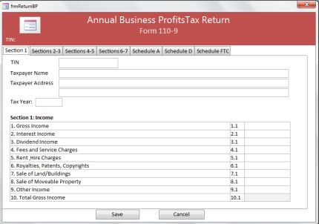

1. If you want to see the already existing returns for a taxpayer, you may select in the main menu REPORTS and then DASHBOARD, inform or search for the TIN and you will get the following screen:

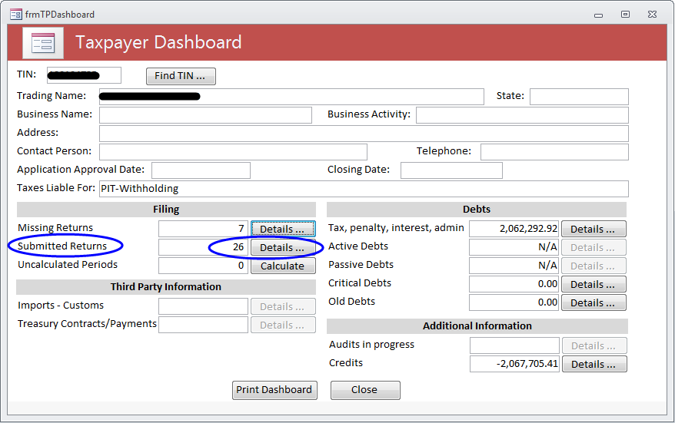

1. Press DETAILS of SUBMITTED RETURNS, both marked in the previous screen, and the following list would be displayed

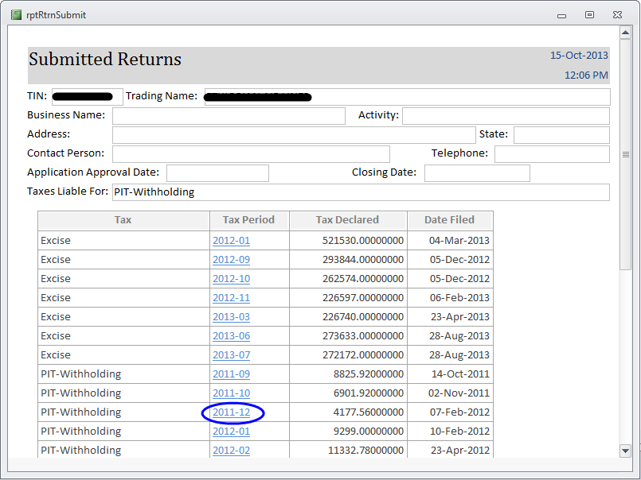

1. Click on the TAX Period and the corresponding return will be presented

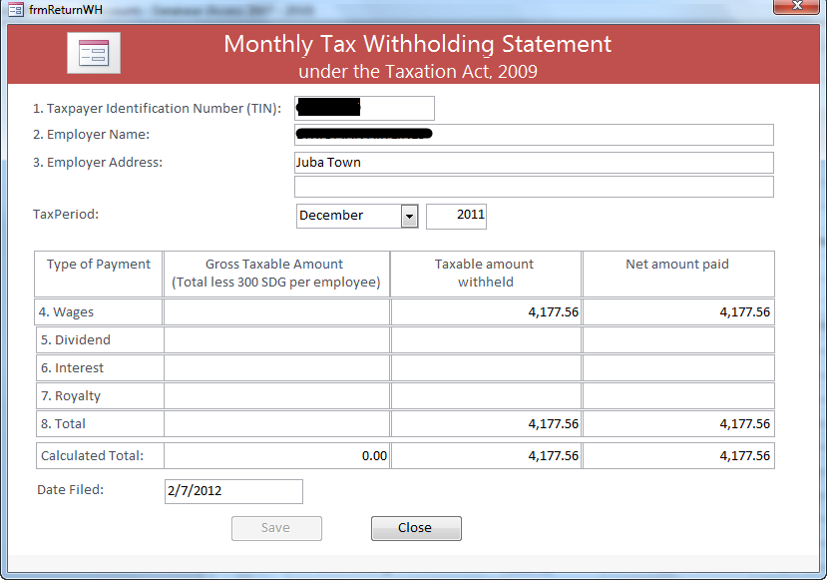

1. Another way of researching the declarations (statements, returns) included for a taxpayer is through its ACCOUNT DETAILS. In the MAIN MENU select TAX ACCOUNTS, enter or search for the TIN, and a list with the balance of each tax the taxpayer is liable for will be displayed:

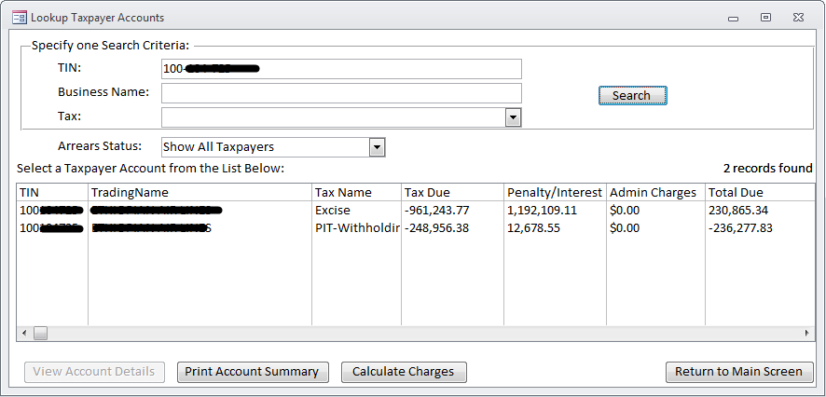

1. Select the tax you want to see the submitted returns by clicking the mouse on the corresponding line, which will be highlighted in black and then press the VIEW ACCOUNT DETAILS button as below

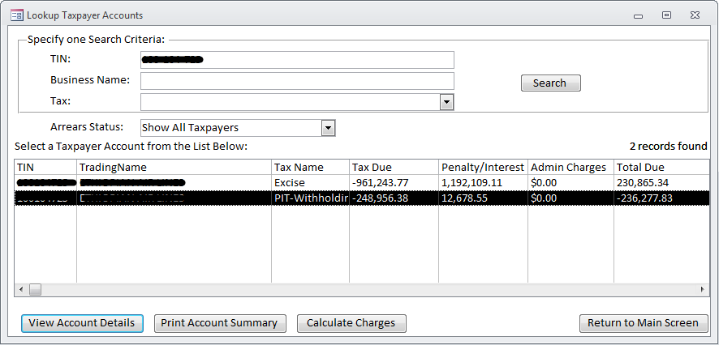

1. The following will be displayed on the screen. Note the scroll bar in the right side, there is a long list of information.

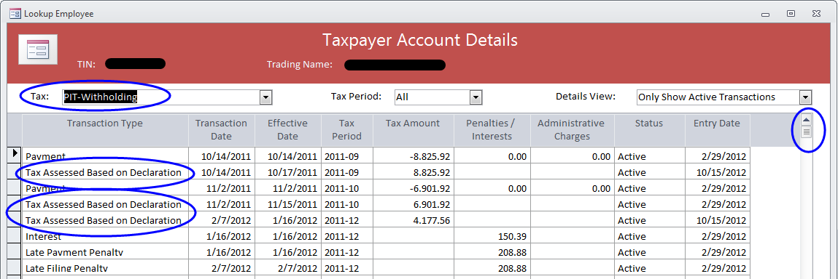

1. The same information can be also printed by clicking PRINT ACCOUNT DETAILS

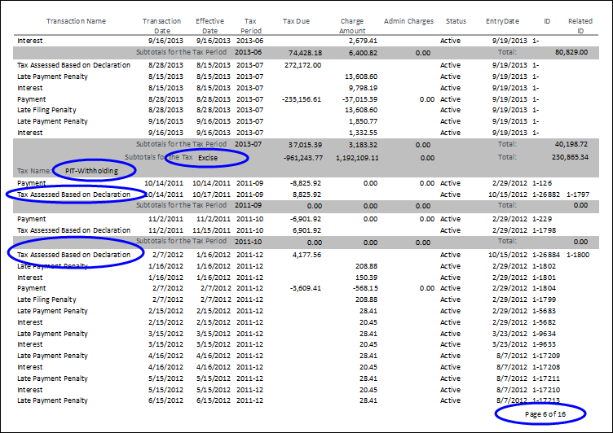

Please note that the printed version includes all types of taxes that the taxpayer is liable for. For every tax, it is listed period by period the payments made, the declarations processed as well as penalties and interest.

## Payments

On this option there are two main functions: Manage Payments and Reconcile Bank Deposits.

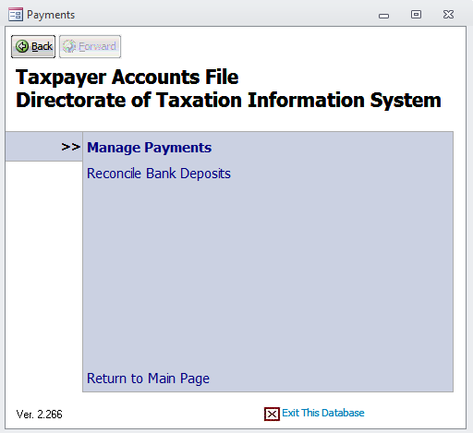

### MANAGE PAYMENTS

On this feature you search, add, view and edit PAYMENTS. The REVERSE option is available only for some users. Just select PAYMENTS in the Main Menu and the following screen will be prompted:

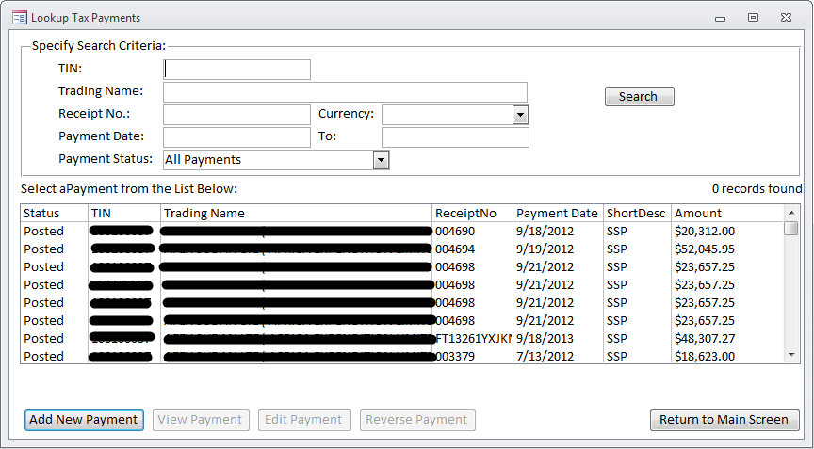

Note that this screen enables you to ADD NEW PAYMENT or to VIEW/EDIT an existing payment. It displays the SEARCH option to be filled and it lists, by default, the Taxpayers classified by TIN.

1. Just press **ADD NEW PAYMENT** and you will be prompted with this question that enables you to choose to use Pay Slip 2 or the Form-15[6].

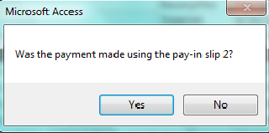

1. Assuming you say “yes”, you will be prompted with the following form:

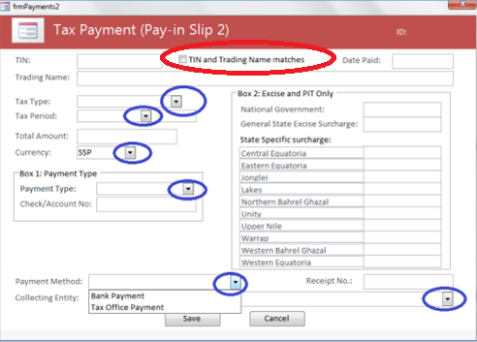

Please note that all fields marked above must be filled with one of the options provided as shown in “Payment Method”. MAKE SURE you verify that the TIN and trading name displayed on the screen matches what is shown on the payment document and CHECK THE BOX “TIN and Trading Name matches”, otherwise the payment will go to the SUSPENDED FILE.

1. Let´s say you want to look for a specific payment made by a specific taxpayer in 2012, but we do not have the exact receipt number. You could make a **SEARCH** as below that returned 15 records:

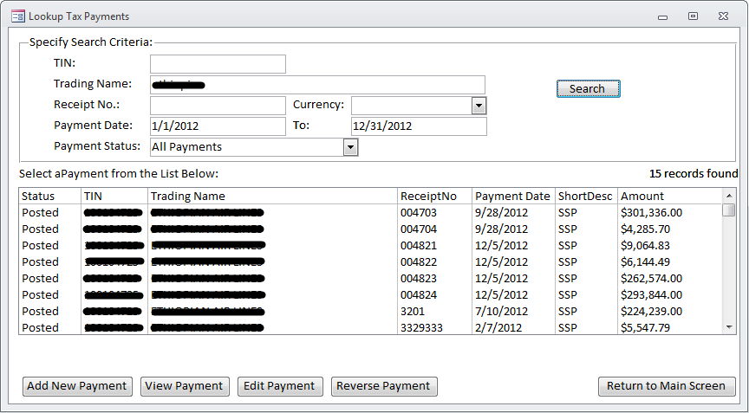

1. In order to VIEW or EDIT any of these payments, just click the mouse on the corresponding line, which will be highlighted in black and press the corresponding button.

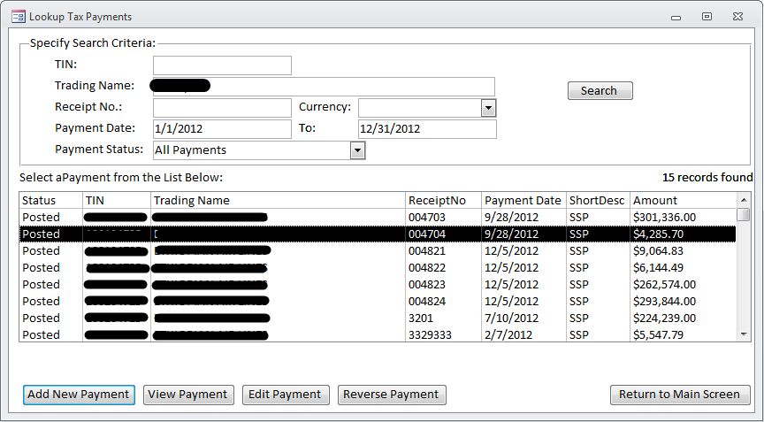

1. The following screen with all details of the payment # 004704 will be displayed:

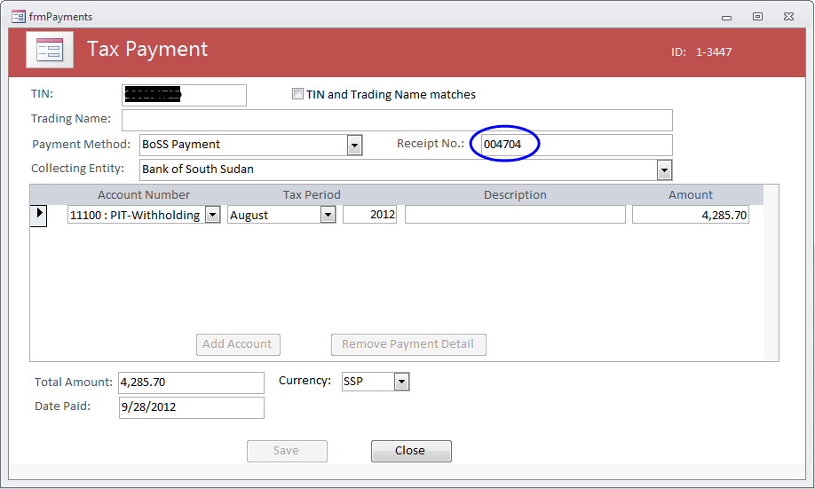

### RECONCILE BANK PAYMENTS

* **SEARCH**

This option is only used by specific users which are responsible to work upon the bank reconciliation. At first you should specify a search criterion to locate the bank deposits you want to have further details. Select the collecting entity and/or deposit date as appropriate, press search button and the result will be displayed as follows:

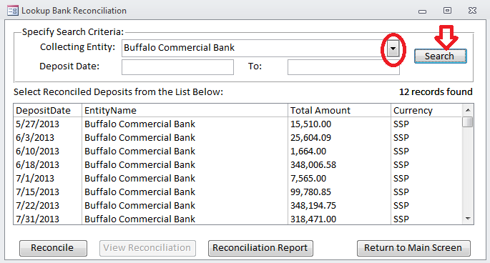

* **RECONCILE**

This option enables the authorized user to reconcile the commercial bank deposits to the Bank of South Sudan with the individual payments. Start the reconciliation process by pressing the RECONCILE button.

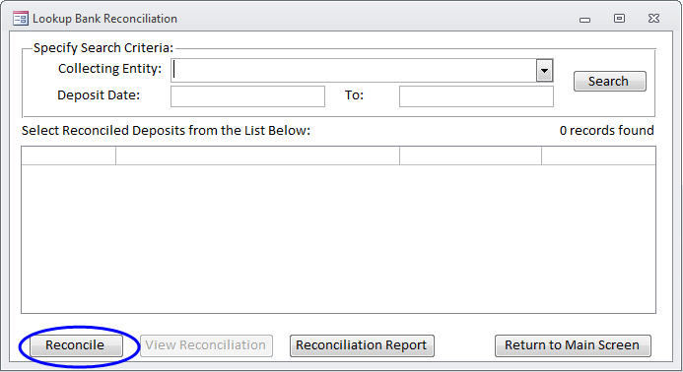

Select the collecting entity that made the deposit and the currency of the deposit. A list of unreconciled transactions that were collected by the collecting entity will be displayed. Enter the date when the deposit was made and the amount of the deposit. Click on all the transactions that were included in the deposit. As you check each transaction, the total amount is calculated and displayed. If the bank charges a transfer fee (normally SSP 10), enter it.

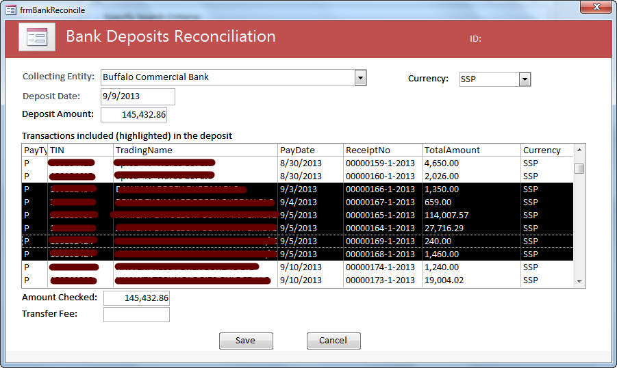

Once all the transactions have been checked, press the SAVE button.

* **VIEW RECONCILIATION**

Mark the Reconciled Deposit you want and press the View Reconciliation Button

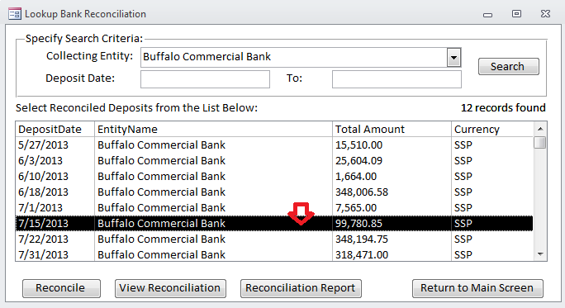

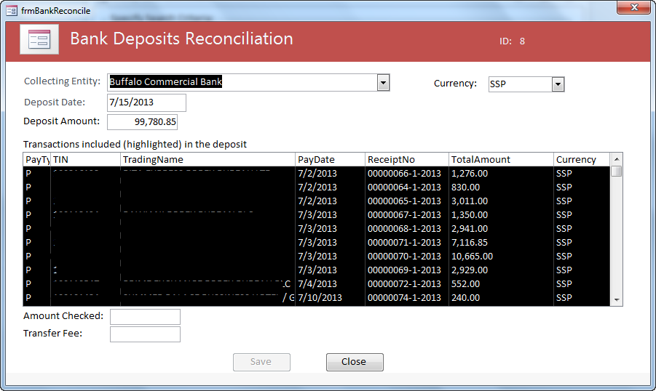

Please note (see first left column) that all transactions were posted (P) into the taxpayer account, otherwise status would be Suspended (S). You can see the taxpayer number and trading name, date of payment, receipt number, amount and currency.

* **RECONCILIATION REPORT**

You can generate a reconciliation report for all reconciled payments matching the search criteria specified by pressing the Reconciliation Report Button to get the following report:

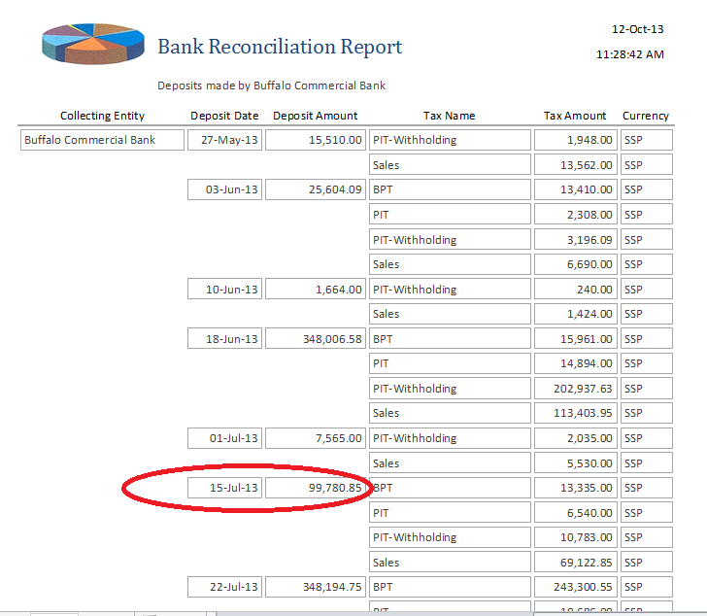

Please note that in this report you can see the same deposit classified by type of taxes (and not by taxpayer) and it is very useful for finances in the process of classifying tax revenues for the budget. This report will need to be sent to the Directorate of Accounts on a regular basis.

## Taxpayers Accounts

This feature offers an overview of the taxpayer situation as it combines the information of the returns and payments. All returns processed and payments posted are attached to the corresponding taxpayer in order to compose his situation with the Tax Administration.

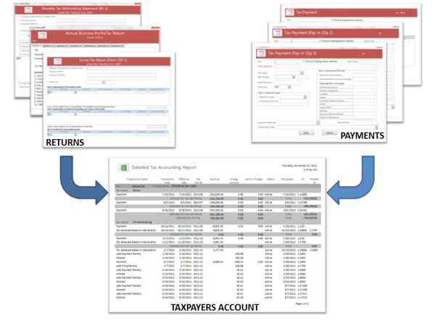

Generally speaking through this feature we can SEARCH the taxpayer, VIEW ACCOUNT DETAILS, PRINT ACCOUNT SUMMARY and CALCULATE CHARGES.

Nevertheless it is possible to use it also to ADD NEW returns and payments, transfer credits and calculate charges, as outlined:

1. In the MAIN MENU select TAX[7] ACCOUNTS option as below

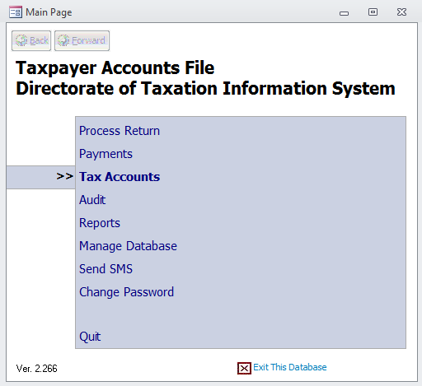

1. The SEARCH feature will be displayed. Enter or search for the desired TIN. A list of the taxpayer´s liabilities is presented

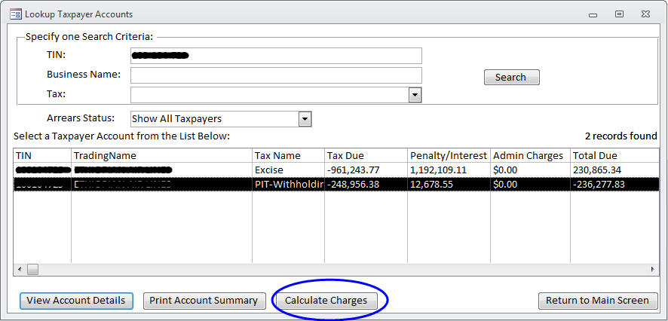

1. The functionalities VIEW ACCOUNT DETAILS and PRINT SUMMARY were already explained under the section “Process Return”, steps 5 to 8. The new functionality that appears on this screen is CALCULATE CHARGES. If you press its button, charges will be **calculated for all the taxpayers** and the following message will be displayed:

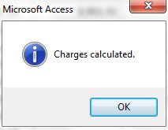 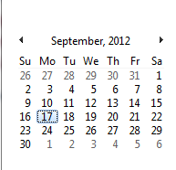

**This option should be selected at least once a month, after the 15th of each month. When selected, the system calculates additional penalties and interests for ALL taxpayers who have debts.**

### CALCULATE CHARGES FOR ALL TAXPAYERS

Special attention must be given to the “CALCULATE CHARGES” feature.

As you know, the tax liabilities (statements and payments) are mostly due on the 15th day of the following month. For instance, the PIT-Withholding of March, 2012 (03-2012) must have its return processed and paid by April 15, 2012.

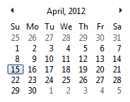As marked in the calendar, it was a Sunday; therefore the due date for payments and returns is postponed to the next working day (Monday).

If the taxpayer has not paid and/or declared the taxes until the 15th (in this case 16) and comes to pay one or many days after, penalties and interest will apply. In this case it should be recalculated on the 17th.

**For this reason it is necessary to calculate the charges every month, in the first working day after the 15th. This function will recalculate all values to the present date and will include one more month of penalties and interest when applicable.**

To better illustrate the functionality of CALCULATE CHARGES we present a report that shows in its last column when the taxes and penalties where last updated (CALCULATE Button) classified by highest amount due.

You can get this report by taking the following steps MAIN MENU 🡺 TAX ACCOUNTS 🡺PRINT ACCOUNT SUMMARY (do not select any taxpayer, just press the button and it will generate a report for all taxpayers).



Press PRINT ACCOUNT SUMMARY as indicated. Note that no taxpayer is selected, so it applies to all.

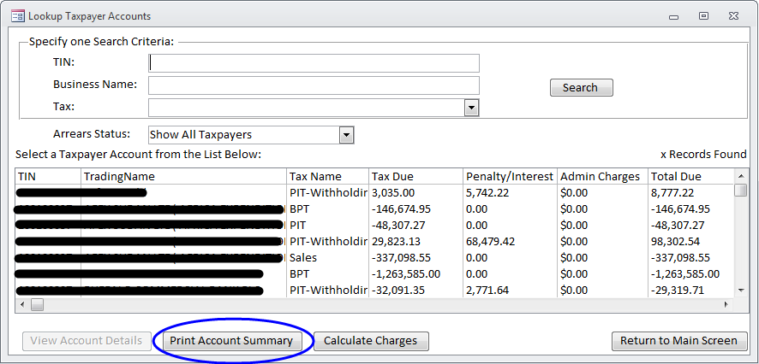

The following report will be displayed, please note the last column to the right (Calculated Through). It informs the date when the charges were last calculated for every taxpayer. Please note that today is supposed to be October 16, 2013; therefore it should be calculated until October 15, 2013 (the corresponding due date).

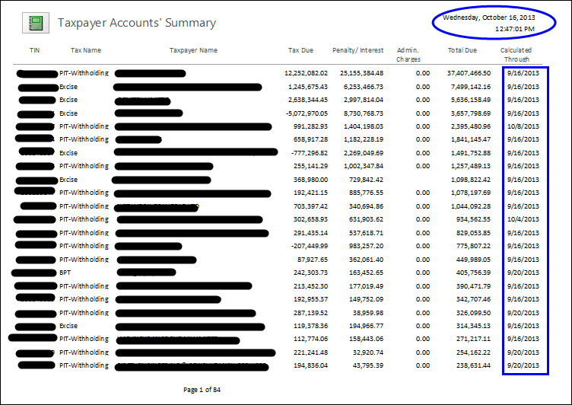

Assuming that today is October 16, 2013 we need to calculate charges as indicated:

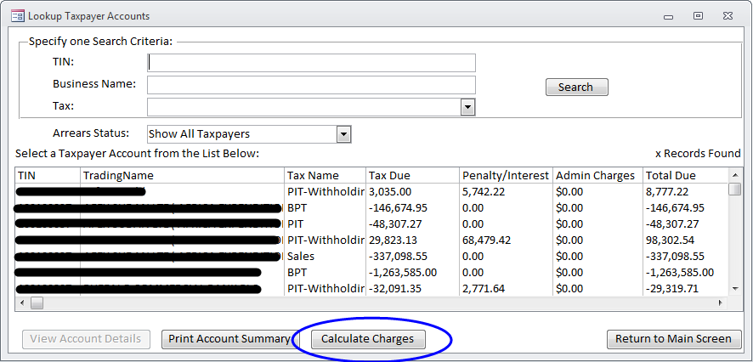

All applicable penalties and interest would be calculated. It might take some time, please be patient. When done, the following would be displayed. Press the OK button.

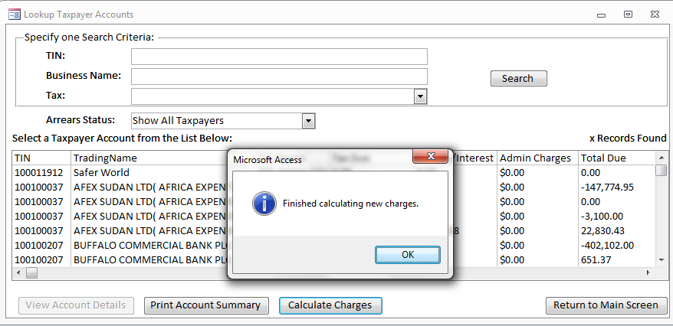

Now print a new account summary, just pressing the corresponding button.



The report shows that all figures are calculated up to the present date. Note that the column “Calculated Through” now has the date of October 15, 2013

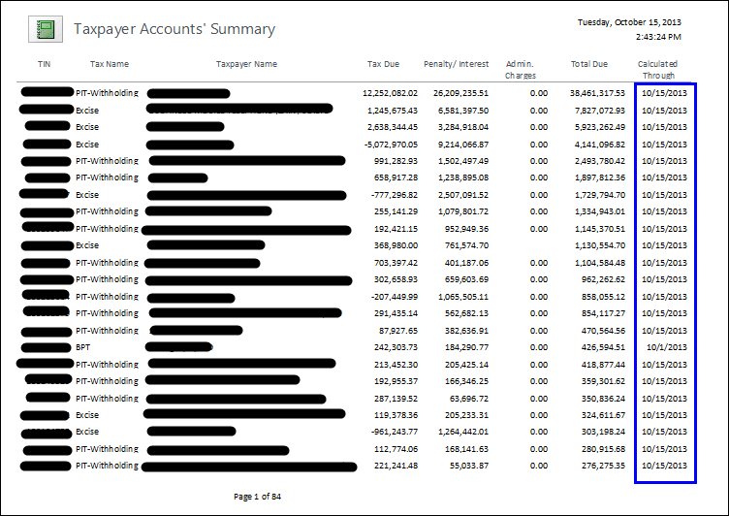

The debt of the first taxpayer in the list changed from 37,407,466.50 SSP to 38,461,317.53, a difference of 1,053,851.03 in just one taxpayer!! So it is very important that you make sure that the CALCULATE is done after the 15th of every month.

### CALCULATE CHARGES FOR ONE SINGLE TAXPAYER

Let´s suppose that penalties and interests were NOT calculated yet for all taxpayers. We can calculate them for the specific taxpayer that we are working at the moment. Just go to MAIN MENU and select TAX ACCOUNTS. Enter the TIN or select the taxpayer from the list. Press the button VIEW ACCOUNT DETAILS as indicated. Note his total debt of 99,212.02 SSP.

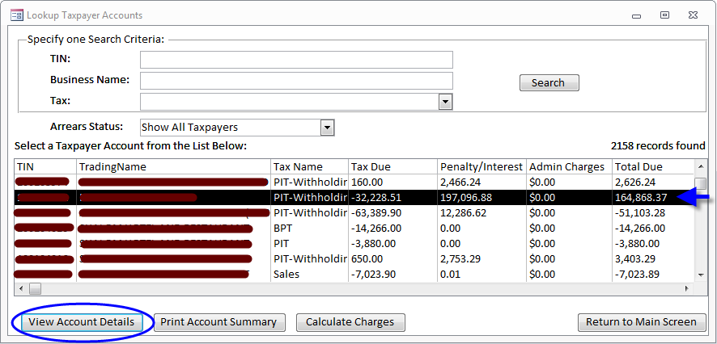

The following screen will be displayed. Note that penalties and interest are calculated until September 16, 2013. Press CALCULATE CHARGES as indicated.

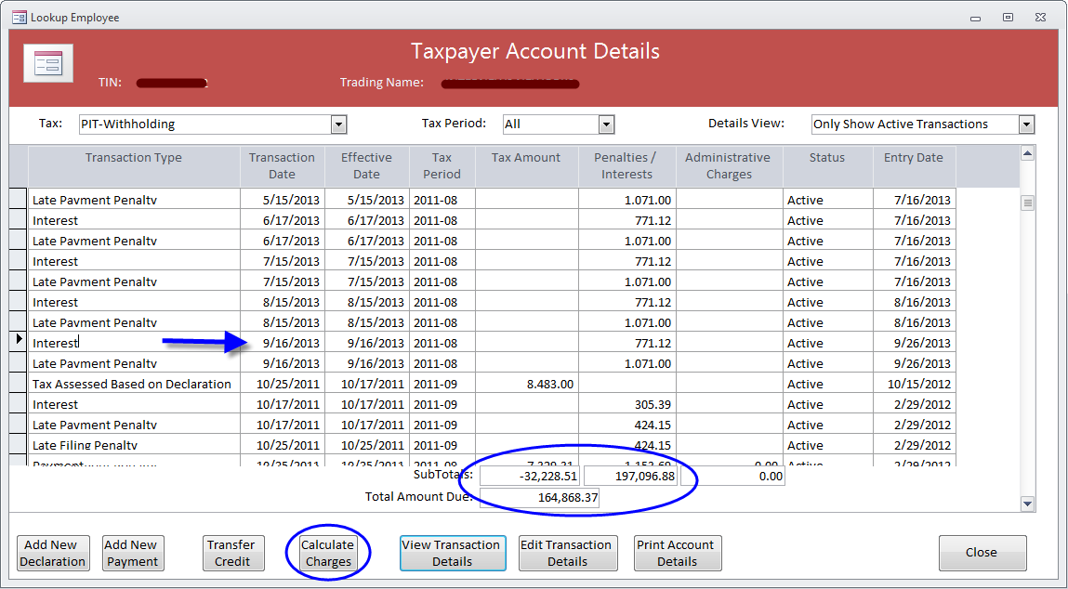

The following message would be displayed. Press OK.

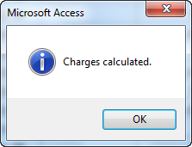

Today is October 16, 2013. Note that charges are calculated until October 15, 2013 and are valid until November 15, 2013. On November 16, 2013 charges for ALL taxpayers should be calculated again. The updated debt is 179,722.95 SSP.

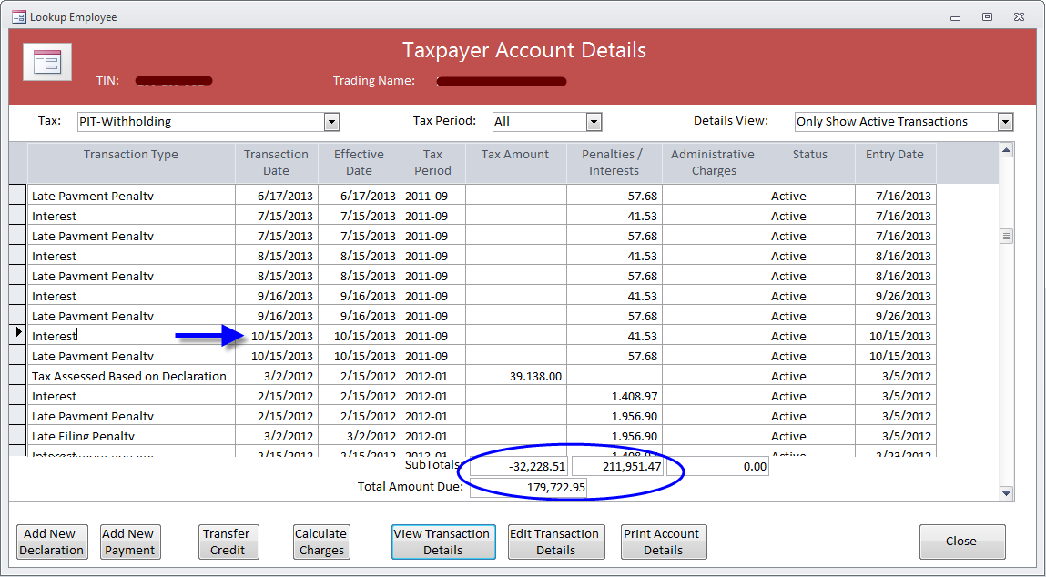

### TRANSFER CREDIT

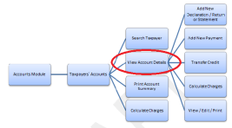As mentioned before the option VIEW ACCOUNT DETAILS can lead you to ADD a NEW RETURN, ADD a NEW PAYMENT, TRANSFER CREDIT, CALCULATE CHARGES, VIEW/EDIT TRANSACTION DETAILS and PRINT ACCOUNT DETAILS.

All these functionalities have been already explained in the previous sections apart from **TRANSFER CREDIT.** It enables the transfer of credits among two taxpayers or within the same taxpayer.

It could be used to correctly post a payment to the right tax period, the right tax, the right taxpayer, or to transfer an overpayment from one period or tax to another. It can also be used to transfer credit to another taxpayer in case the payment was posted to the wrong one.

1. Select VIEW ACCOUNT DETAILS as indicated below

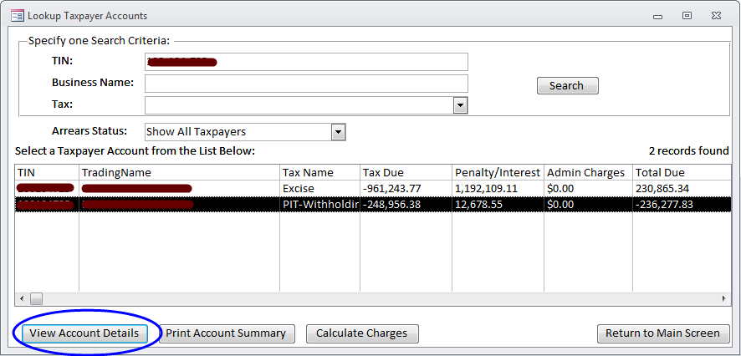

1. Then select TRANSFER CREDIT as shown below

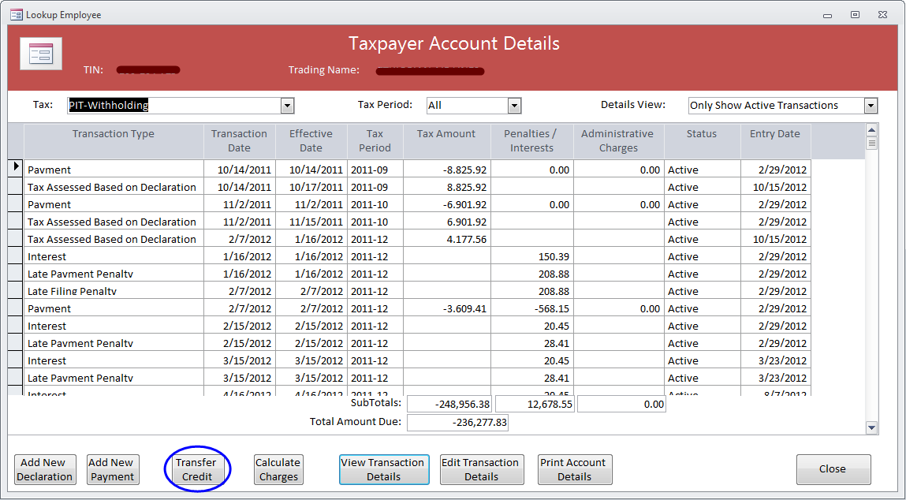

1. Select TAX type and period and the system will display the available credit

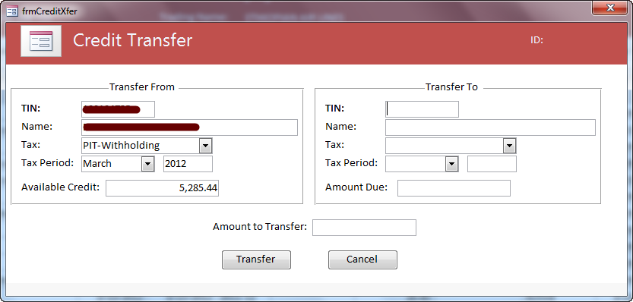

1. Enter the TIN of the taxpayer that the amount would be transferred to; the system will display its Business Name. Make sure it is the correct taxpayer. Type in TAX type and period; the system will display the amount due. Just key in the amount to be transferred.

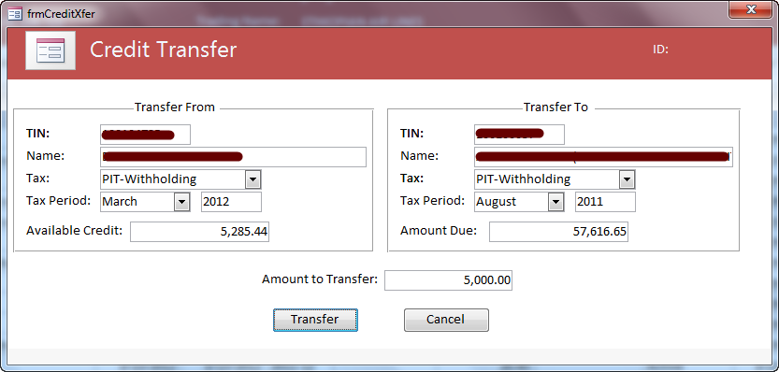

1. The transfer transaction will appear in the Account Details of both taxpayers: origin and destination as below

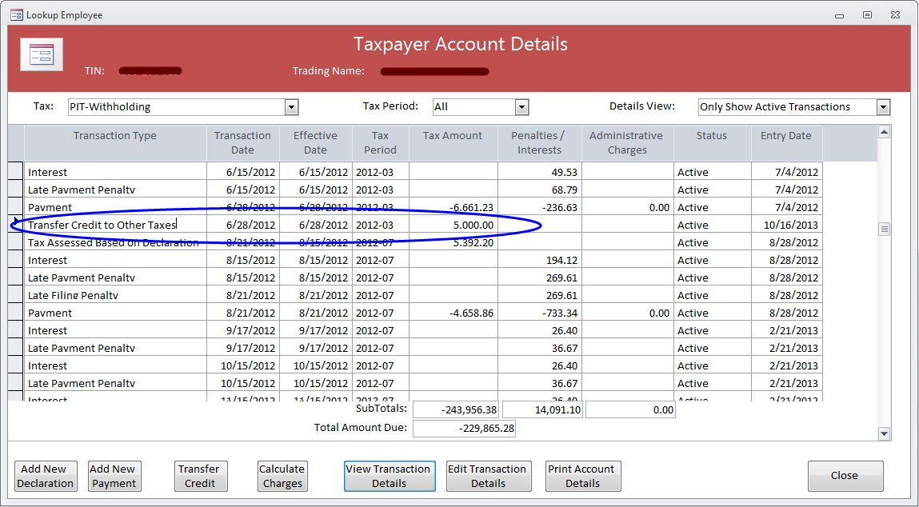

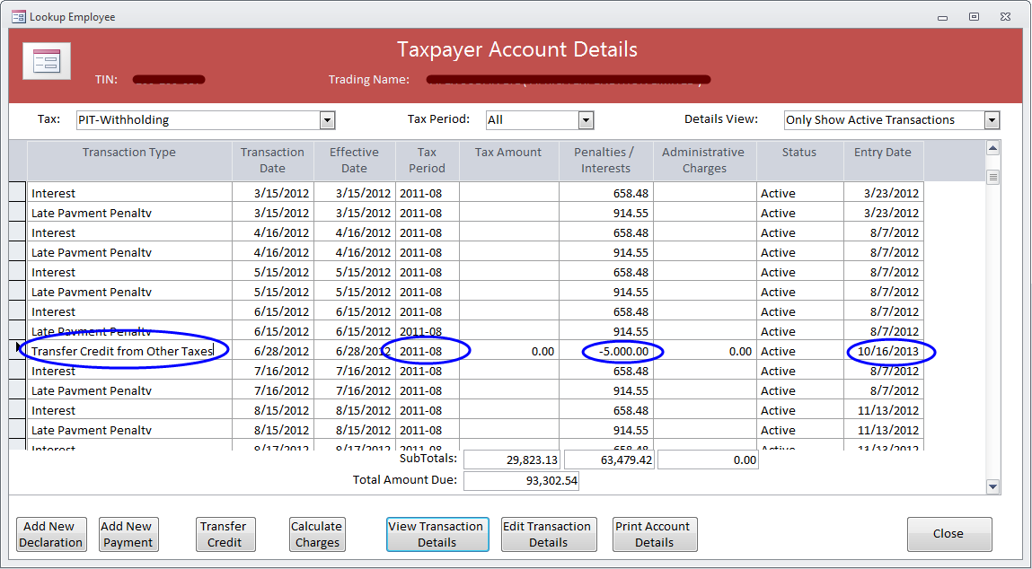

## Audit

The Directorate of Taxation and Audit Unit in particular are working towards achieving maximum voluntary compliance. Taxpayers operate on self-assessment of their tax obligations.

Aktiviteti efektive i kontrollit eshte nje vegel shume e rendeishme ne zhvillimin e nje  sistemit te përmbushjes vullnetare tatimore, menaxhimin e jopermbushjes (jo deklruesve) dhe rujtjen apo kolektimin e te hyrave, por kjo eshte etem nje vegel.Effective audit activity is a very important tool in developing this system of voluntary tax compliance. Under-declaration of liabilities may be a result of an innocent error or deliberate action.

Therefore after the Audit is completed it is necessary to include its results in the System. We can understand an Audit as an assessment made by the Tax Administration as opposed to the self-assessment made by the taxpayer. As a consequence of the Audit an Audit Return is produced.

1. Select AUDIT from the MAIN MENU

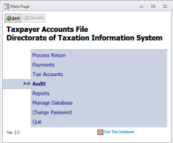

1. Press NEW AUDIT

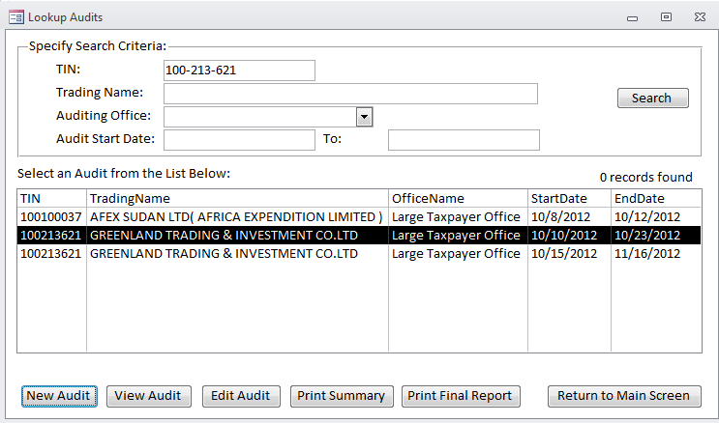

1. Fill in the information of the Audit concerning start and end date, office and auditors. Then choose the type of tax from the options displayed. Presently only PIT-Withholding and Excise is available.

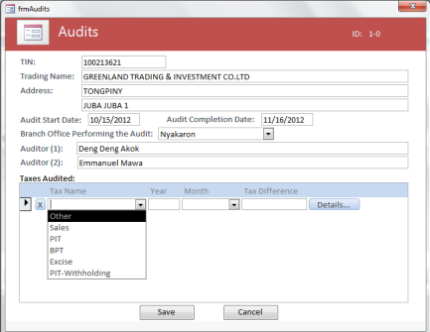

1. Enter the period (month and year) for which the audit was done and click DETAILS

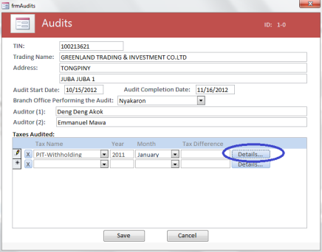

1. Then the Auditor will input the required information according to his audit papers and documents and press SAVE. Please note that the “declared” information is colored gray and disabled for editing: this happens because the taxpayer has not submitted the corresponding tax return.

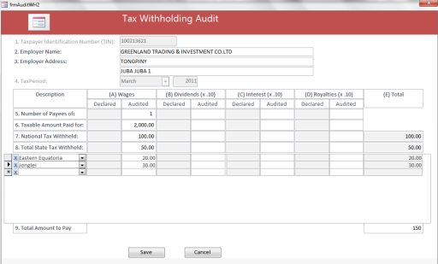

1. Type all periods that were audited and when completed press SAVE

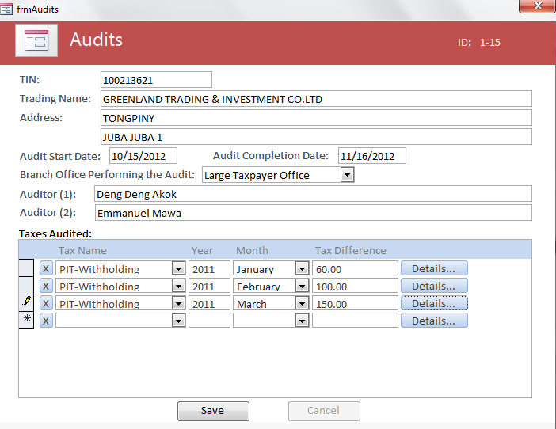

1. In the example below the “declared” information is automatically displayed by the system according to a corresponding tax return previously submitted by taxpayer.

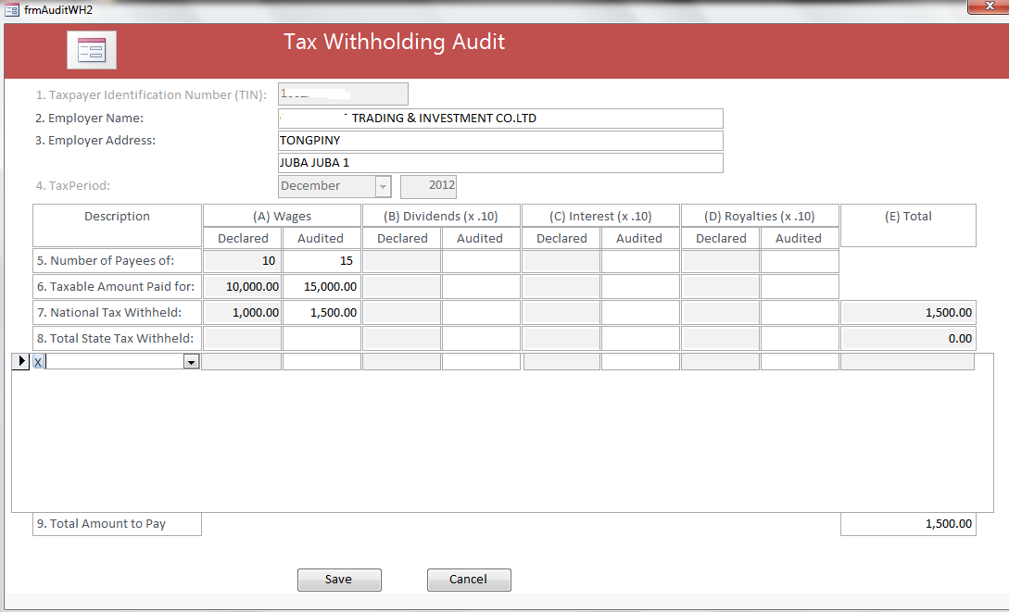

1. The audit is now included in the system as indicated below

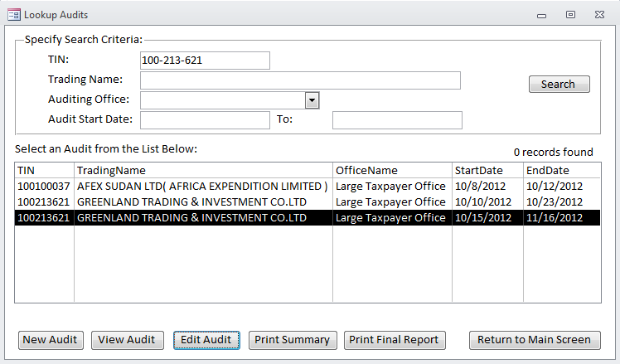

1. Press PRINT SUMMARY to obtain the summary of the audit

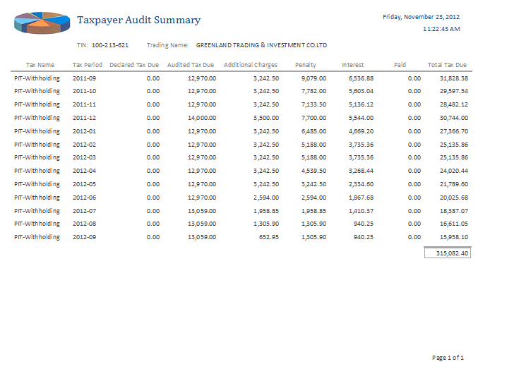

1. Select PRINT FINAL REPORT to get the legal document to be signed and attached to the audit documentation

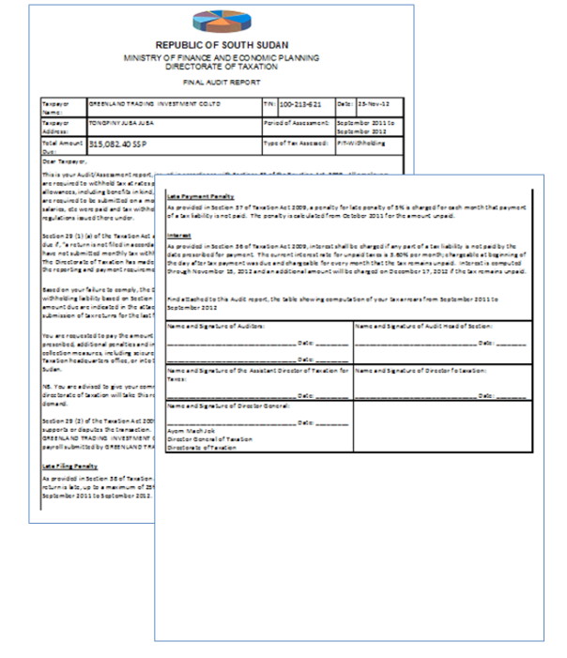

## Reports

1. In the MAIN MENU select REPORTS option as below

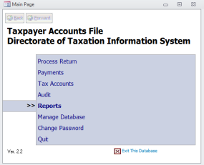

1. The following reports are available in this module

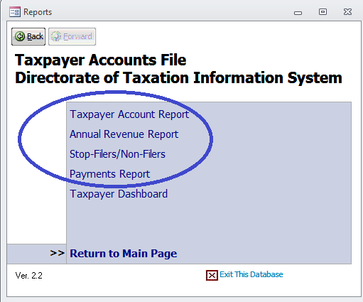

The first four reports (Taxpayer Account Report, Annual Revenue Report, Stop-Filers /Non-Filers and Payments) are reports that contain information of all taxpayers or some taxpayers according to a selection criterion (filter).

1. The last report is a report of a single taxpayer, it is the DASHBOARD, which consolidates all information of one taxpayers´ accounts.

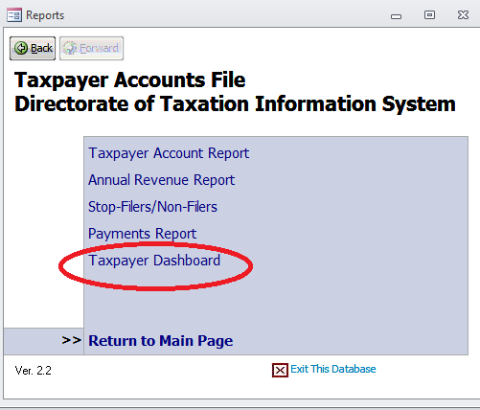

To get any of these reports just click on the corresponding option. Below we describe each one in detail.

### TAXPAYERS ACCOUNT REPORT

As you choose this report you must select if you want a detailed or a summarized version. You should also enter the Type of Tax, the State, Assigned Office and Business Activity by selecting one of the available options as marked below. If no selection is made, ALL is assumed.

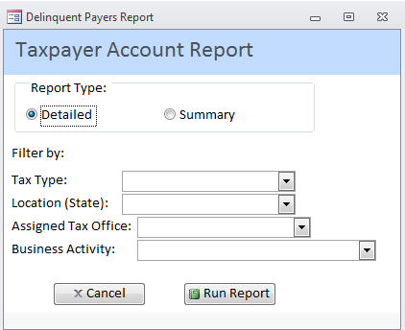

1. If we want a summarized report of PIT-Withholding in Lakes State these are the options to be selected. Please note that Assigned Tax Office was left blank since it makes no difference as there is only one Office in Lakes State. Remember that a taxpayer may be located in Lakes State and assigned to LTU.

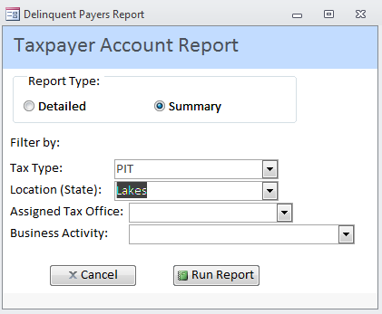

1. Press RUN REPORT as indicated above. The following report will be produced. Note the criterion used on report as indicated on its header.

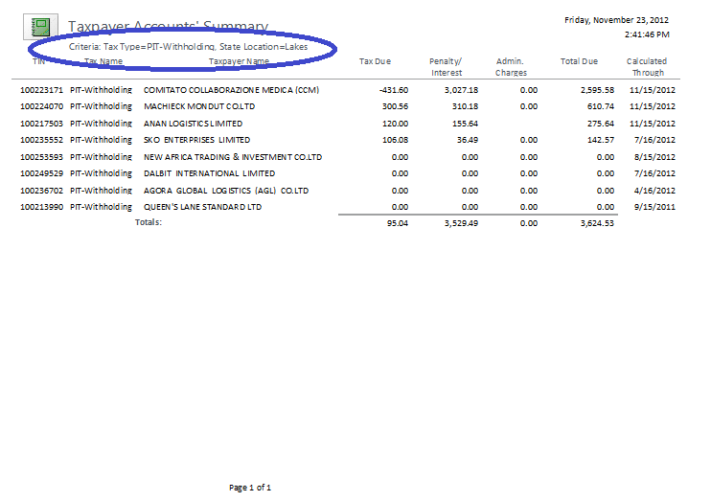

### ANNUAL REVENUE REPORT

This is an incremental yearly report in the sense that every month new data will be reported. It can be grouped up to two levels by tax type, office and month and the third level will present the details. If we want to group in just one level (like below) than we choose “None” for the second level.

Check the option “Roll up to major tax” if you want PIT-Withholding to be considered together with PIT itself. If you leave this unchecked then you will get data from PIT -Withholding separated from PIT. So when selecting “Roll up to major tax” the sub taxes will be reported as part of the major tax.

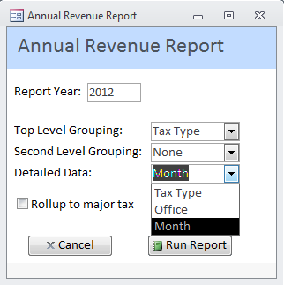

Press RUN REPORT and this will be the output: Top Level Grouping by TAX TYPE (marked blue) and Detailed Data by MONTH (marked red)

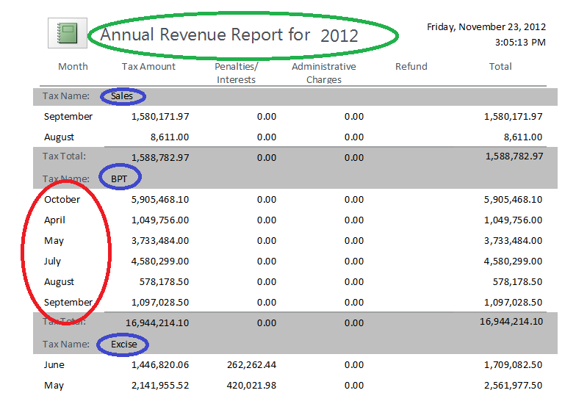

### STOP-FILERS / NON-FILERS REPORT

This report searches the database considering: Tax Type (if left blank it will consider all taxes), Period (from /to) and Minimum Estimated Annual Revenue (if left blank, it will consider any amount). You can produce reports of taxpayers that have missed at least one period or that have never filed a return. It is also possible to check the situation of one or more specific taxpayers.

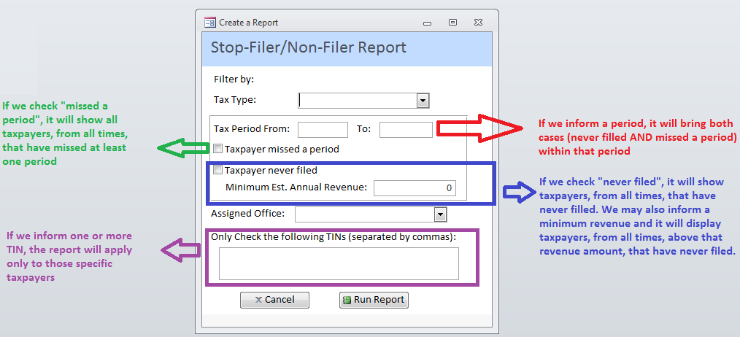

See the following examples to illustrate some of the possibilities offered by this report:

1. Taxpayers of **any tax** liability that had **never filed** a return at any period and have registered with estimated annual revenue of **500.000 SSP**

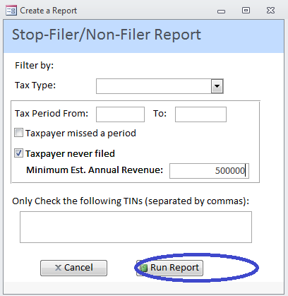

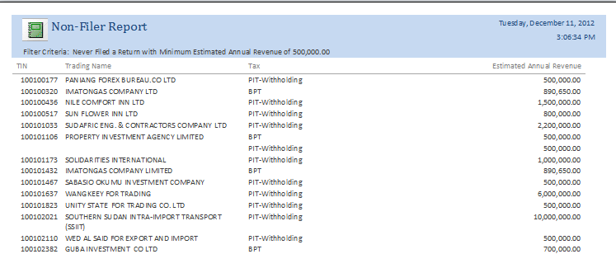

(….) pages 2 to 32

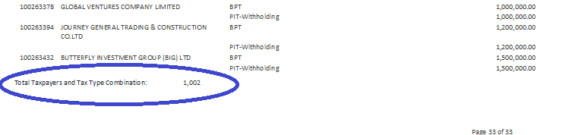

**There are 1002 Taxpayers in this situation! Note that it is counted one more for every tax liability of the same taxpayer.**

1. Taxpayers liable for PIT-Withholding who has filed before but missed at least one period. You cannot enter a period, the system will consider all database.

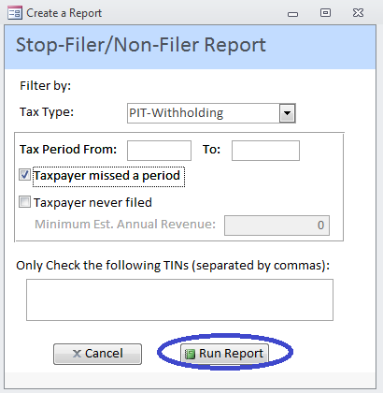

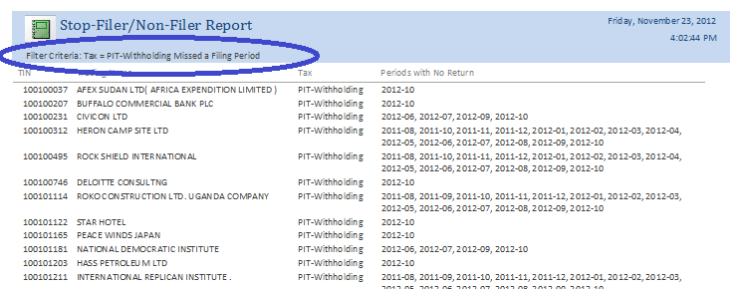

(…) Pages 2 to 45

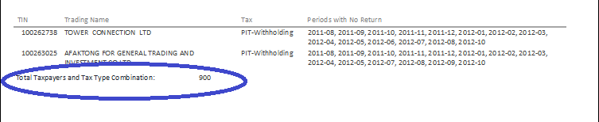

**There are 900 taxpayers in this situation! Note that it is counted one more for every tax liability of the same taxpayer.**

1. Taxpayers liable for PIT-Withholding that have not submitted returns from Jan/2012 to Oct/2012. Please note that if you select a Period (from/to) the system will search missed returns and never filed returns, therefore the corresponding check boxes are disabled.

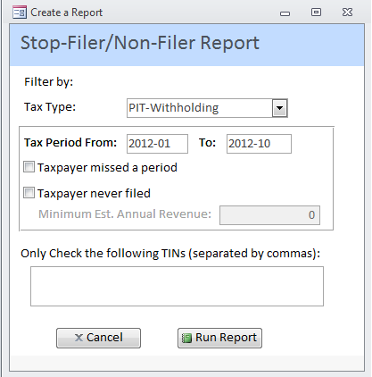

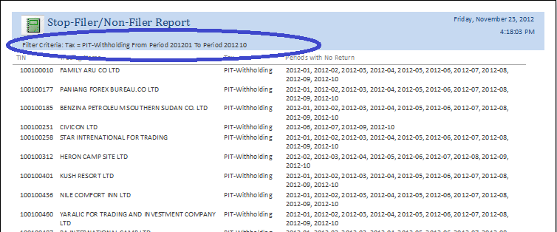

(…) Page 2 to 318

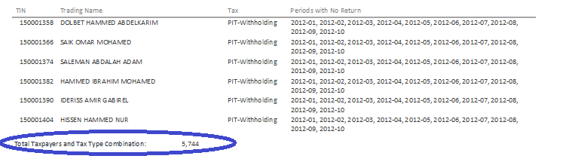

**There are 5.744 taxpayers in this situation! Note that it is counted one more for every tax liability of the same taxpayer.**

1. Check the situation concerning file returns of specific taxpayers by entering the TIN. No other option needs to be provided. The System will consider all taxes at any time.

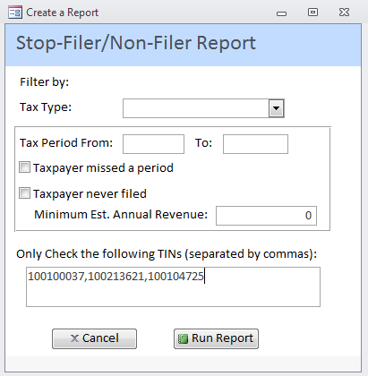

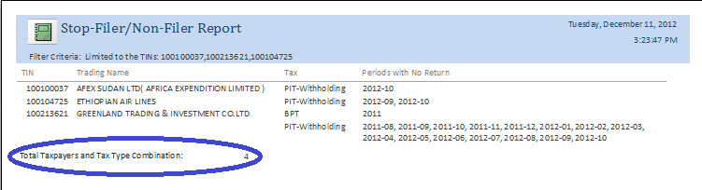

**There are 4 taxpayers in this situation! Note that it is counted one more for every tax liability of the same taxpayer.**

### PAYMENTS REPORT

This report about payments provides detailed and summarized information according to the option selected by the user.

It can be grouped by various options: Payment Date, Taxpayer, Payment Method, Collecting Entity, Tax Type and Tax Period. No grouping option is also available. The user must check one of the options.

The information can be filtered by various criterions: Payment Date (from/to), TIN, Tax Type, Tax Period, Collecting Entity and Assigned Tax Office. Most filters are selected from a list of options as marked in blue. It is optional to have a filter. If no filter is provided then the report will be made upon the entire data base.

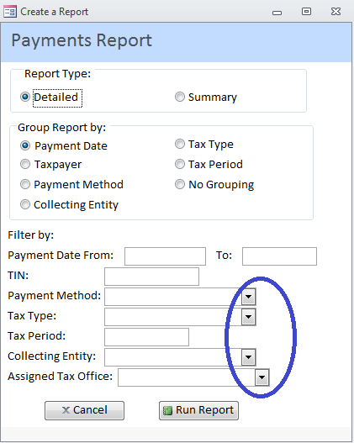

Due to so many options this is a very flexible reporting feature concerning payments. We will present a few examples to illustrate the possibilities.

1. All payments of a taxpayer grouped by date can be obtained as below

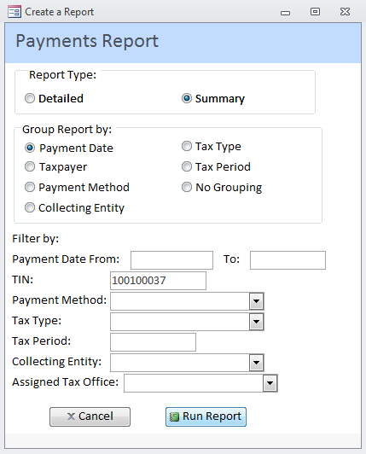

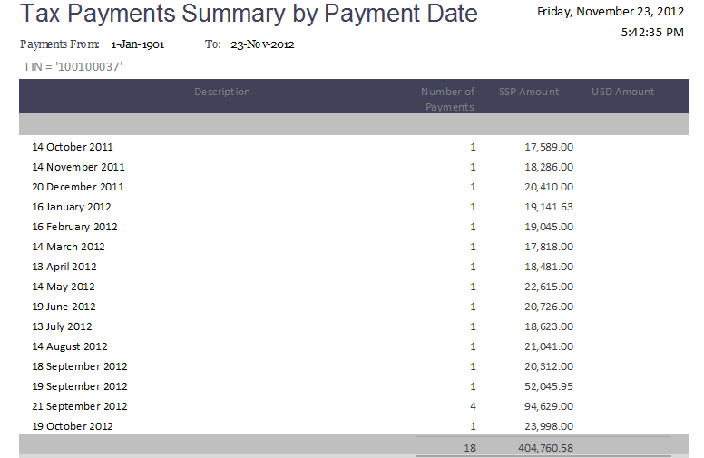

1. All payments of October, 2012 grouped by taxpayer

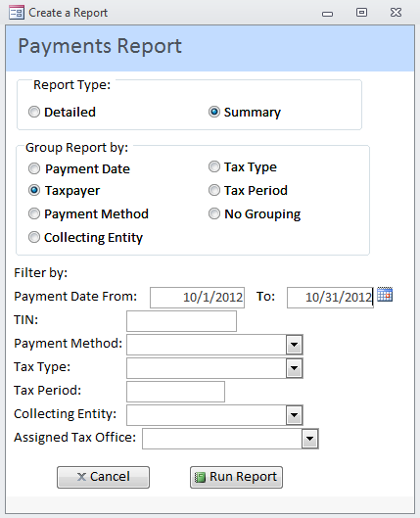

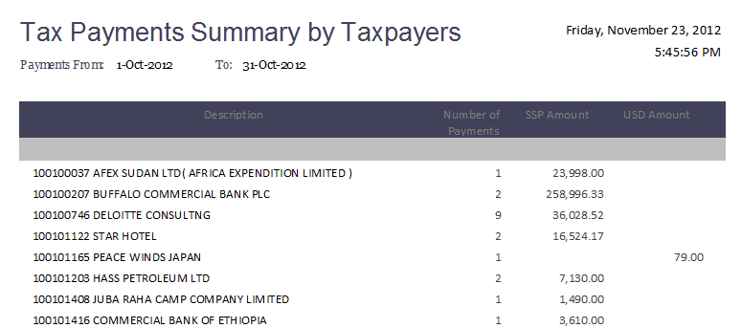

This is the first page of the report grouped by taxpayer, classified by TIN.

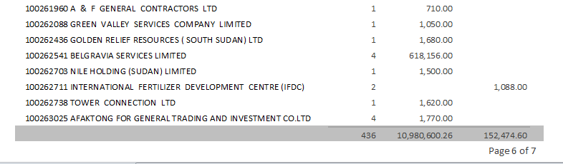This is page 6 and it presents the last posted payments of October, 2012.

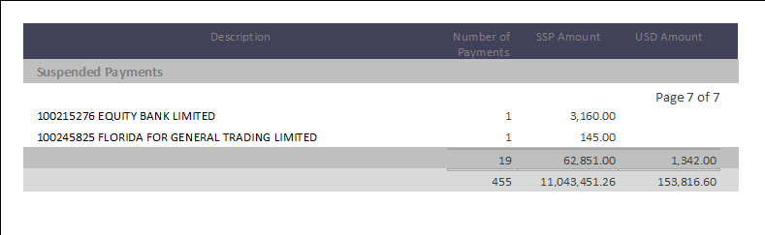This last page presents the suspended payments of October, 2012

1. Summary of payments of PIT-Withholding grouped by Payment Method

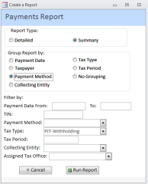

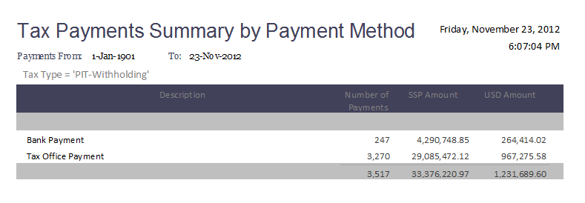

1. The same options used before but with a detailed information would produce the following report:

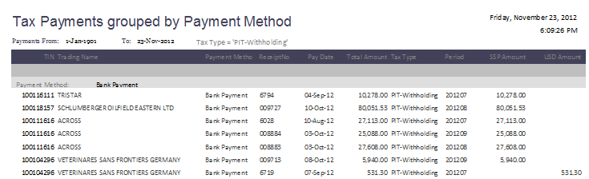

Above we see the first page of the report with the payments made at the bank (payment method)!

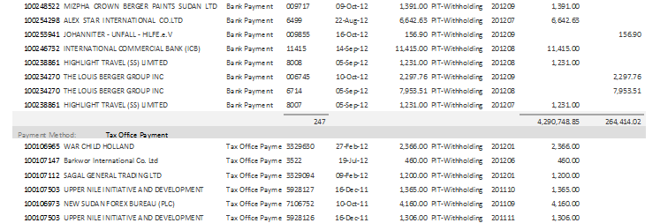

An intermediate page 9 of the report shows: 247 Bank Payments and the start of the Tax Office Payments. Please note that we have grouped by Payment Method.

### TAXPAYER DASHBOARD

This is the consolidated account information of one single taxpayer. All the information under the DETAILS button can be displayed and printed.

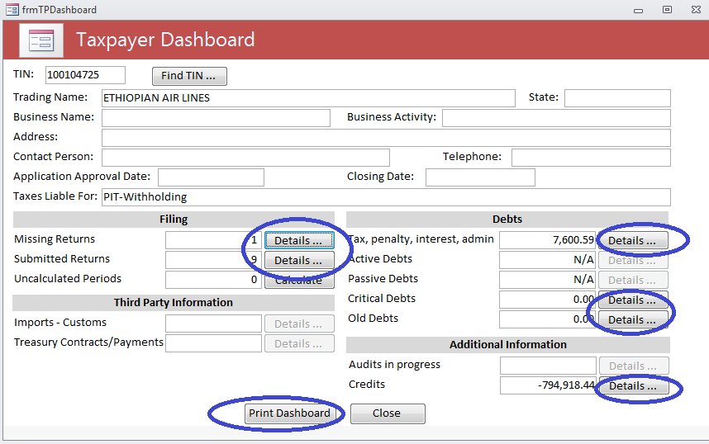

1. Pressing DETAILS of MISSING RETURNS the following screen will be displayed

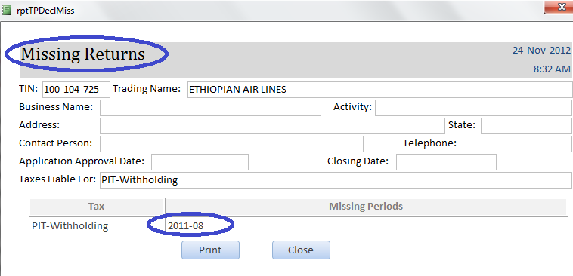

1. Below are the DETAILS of SUBMITTED RETURNS

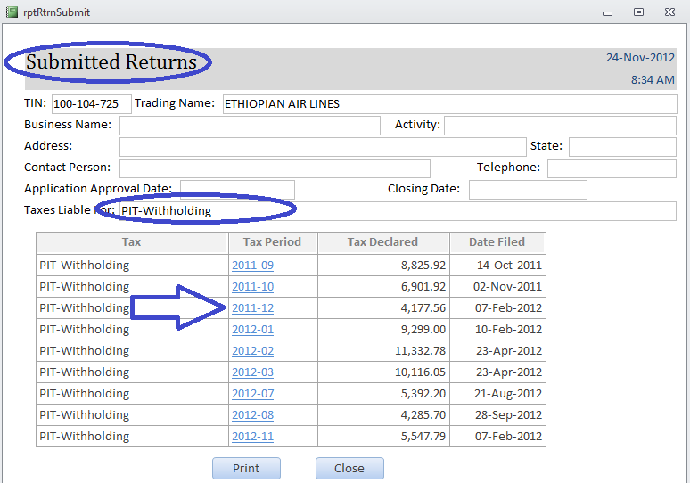

1. If you click in the (as indicated by the arrow above) Tax Period you will get further information as below

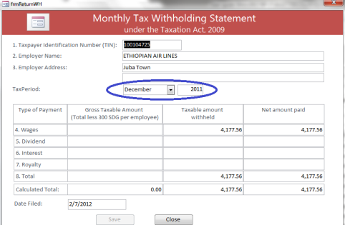

1. Clicking in the DETAILS of Tax, Penalty, Interest you will get all the Taxpayers Liabilities and Arrears as below. To get the latest arrears, make sure there are **no** **uncalculated periods showing in the dashboard**. If there is, first click on the CALCULATE button in the DASHBOARD

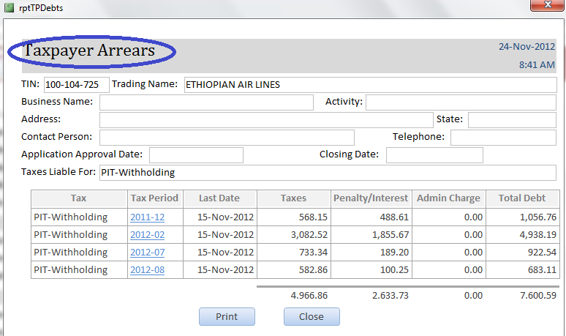

1. If you need additional information of one specific Tax Period just click on it as indicated above

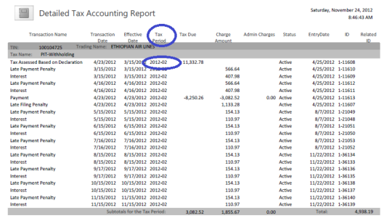

1. Information about CREDITS can also be further detailed as below

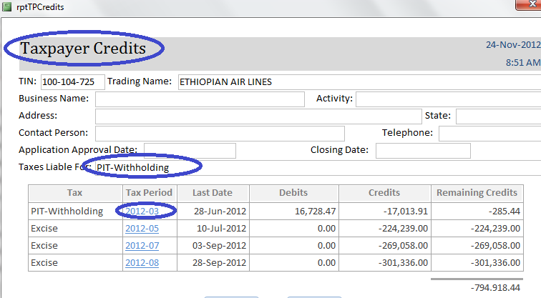

1. If you click on the specific Tax Period as indicated above you can drill down the information as follows

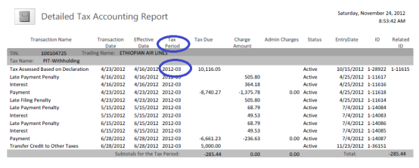

1. In the dashboard, on the right bottom side, you can see the following information:

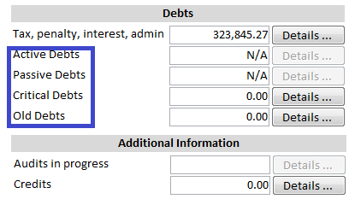

* Active and Passive Debts are currently not defined therefore it is showing as N/A.
* Critical debts are all debts that are within 2 months of the 6 years statute of limitation.
* Old debts are any debts older than 2 years.

1. In the dashboard, on the left bottom side, you can get information about the situation of the taxpayer with third parties, such as Customs and Finances. This feature is not implemented yet, therefore the DETAILS button is disabled. Once there is integration with these other government institutions such data will be made available.

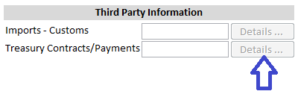

## Send SMS

This feature was designed to send predefined messages to taxpayers reminding their obligations with the Directorate of Taxation. It is available only for authorized users. Messages of arrears, stop file or due date reminders can be sent to the applicable taxpayers. If other contents are necessary the system administration should be contacted.

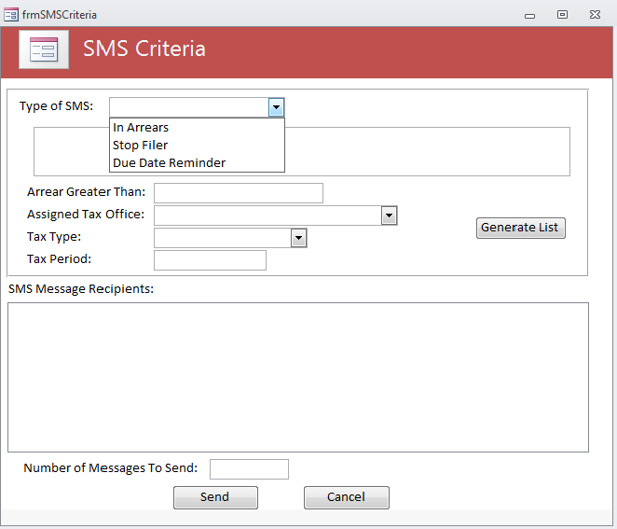

Select the type of message and the other possible filters such as assigned office, tax type and tax period. Press button Generate List and then press Send button. A MTN modem with credit must be inserted in the USB port of the computer.

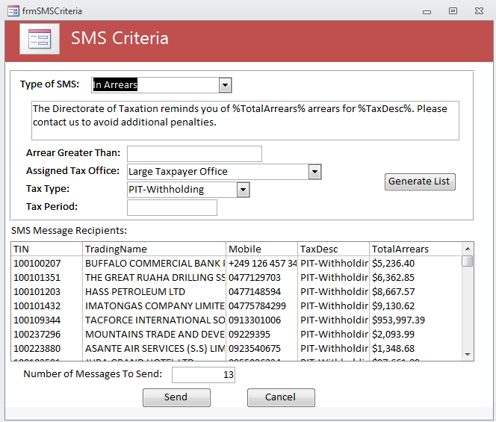

# Frequently Asked Questions

### How do I get taxpayers returns submissions?

### How do I get an Audit assessment return?

### How to find out about partial payment of taxes?

### How to know about late payment of submitted returns?

### How to list non-filers and late filing of tax returns?

### How do I make a report to select a subset of taxpayers that meet some specific criteria?

### What is an uncalculated period?

### What investigations and research can be made using the System that could lead to an Audit Assessment? (See Clearance Procedure Guide)

1. User ID stands for User Identification.
2. Please note that results of the examples throughout this guide may vary depending on the version of the test database.
3. Portable Document Format (**PDF**) is an open standard for electronic document exchange.
4. Portable Document Format (**PDF**) is an open standard for electronic document exchange.
5. Type of business such as: accommodation, finances, etc.
6. There are still some payments made in the old form, but this tends to disappear and be entirely replaced by Pay Slip 2.
7. Taxpayers Accounts